***Comparative Sentiment Analysis in Traditional vs. Digital Banking:  
The Case of Deutsche Bank and N26***

1. **Executive Summary**

Germany leads the global FinTech landscape as the fourth-largest market worldwide and the largest within the EU, driven by its robust digital infrastructure (ITA, 2023). Traditional banks and emerging FinTechs exhibit divergent organizational cultures, highlighting the importance of understanding employee sentiment for maintaining a competitive edge. Through systematic exploration, data preprocessing, topic modeling, K-means clustering, and sentiment analysis of Glassdoor reviews, the project, titled *“Comparative Sentiment Analysis in Traditional vs. Digital Banking: The Case of Deutsche Bank and N26”*, aims to uncover differences in job satisfaction and organizational culture, providing insights into the banking sector's dynamics.

**Key Findings:**

* **Exploratory Data Analysis (EDA):** Deutsche Bank has multiple office locations, while N26 is centralized in Berlin. Job titles at Deutsche Bank vary widely, whereas N26 reviews mainly come from anonymous employees and software engineers. Deutsche Bank receives 4-star ratings, whereas N26 ratings range from 3 to 5 stars.
* **Clustering Classification:** At Deutsche Bank, positive feedback centers on teamwork and work opportunities, while negative comments focus on compensation and career progression. Conversely, N26 employees are satisfied with flexible team dynamics and development opportunities but express concerns about internal politics and management practices.
* **Employee Sentiment Analysis:** N26 exhibits higher positive sentiment across all aspects, particularly in compensation and career progression, compared to Deutsche Bank.
* **Employee Sentiment Through Work Aspects:** 
  + ***Compensation:*** *While Deutsche Bank receives mixed sentiment regarding salary, N26's employees overwhelmingly express satisfaction with both salary and benefits.*
  + ***Collaboration:*** *Both organizations exhibit strong positive sentiments towards colleagues and teamwork, indicating supportive workplace cultures.*
  + ***Management and Leadership:*** *Satisfaction with managers and leaders is generally high at both companies, but negative sentiment towards management is more prevalent at N26.*
  + ***Work-Life Balance:*** *Deutsche Bank employees perceive a higher level of positivity regarding work-life balance compared to N26.*
  + ***Company Culture:*** *Employees at both companies report high satisfaction with the company culture and the work environment.*
  + ***Career Progression:*** *N26 employees express more positivity toward career opportunities compared to Deutsche Bank, where there are mixed feelings, especially about promotions.*

The comparative analysis of employee sentiment reveals that N26 stands out with higher levels of employee satisfaction regarding salary, benefits, and career opportunities compared to Deutsche Bank, reflecting a company culture that prioritizes and supports employee development. While employees from both institutions appreciate the collaborative environment, work-life balance, and company culture, N26 faces challenges in management perception. Conversely, Deutsche Bank displays a wider spectrum of sentiments, particularly regarding negative feedback on career progression. To remain competitive, Deutsche Bank should reevaluate its compensation structures and career advancement pathways, aligning them with the progressive practices observed in FinTechs like N26, which resonate better with employees.

1. **Introduction and Motivation**

According to the official websites of the International Trade Administration (ITA) and Germany Trade and Invest (GTAI), Germany leads the global financial technology (FinTech) landscape, positioned as the fourth-largest market worldwide and the largest within the European Union. Germany's FinTech demand and market size are expected to grow continuously, as the country offers a robust digital infrastructure to meet customers’ growing demand for innovative financial services (ITA, 2023). As Germany’s financial sector rapidly evolves through digital transformation, traditional banks and FinTech firms exhibit distinct organizational structures and cultures. Understanding employee sentiment is vital to maintaining operational efficiency for competitive advantage. This leads to my research question: ***how do employee reviews reflect the differences in job satisfaction and organizational culture between traditional banks (Deutsche Bank) and FinTech companies (N26)?***

The hypothesis is that analyzing employee reviews will reveal distinct sentiment trends and themes related to job satisfaction, management practices, and work-life balance across traditional banks, exemplified by Deutsche Bank, and FinTech companies such as N26. The paper by Ramanathan and Thirunavukkarasu (2019) mentions the Maslow theory, describing 5 hierarchy stages of needs (psychological needs, safety needs, social belonging needs, esteem needs, and self-actualization needs) which can help me identify the direction of employee sentiment within the organizations. Regarding my assumption, N26, one of the FinTech companies, will exhibit more positive employee sentiment compared to Deutsche Bank, one of the traditional banks. Contrasting theories suggest that traditional banks’ stability may foster equally positive employee sentiment. However, this project aims to provide actionable insights into organizational culture and areas for improvement.

The motivation behind this research comes from the contrasting organizational structures and cultures between traditional banks and emerging FinTech firms through the rapid evolution of the financial sector. Employee satisfaction significantly influences banks’ operational efficiency, particularly in Germany's rapidly digitizing financial service industry. Additionally, my career journey in the FinTech sector drives my curiosity to explore how varying organizational structures impact employee sentiment, especially as I consider an internship in the financial services industry.

This research is crucial for understanding which organizational structure aligns with my professional goals in both traditional and digital banking. Analyzing employee reviews from Deutsche Bank and N26 not only enhances industry knowledge on talent retention and organizational development but also informs my choice of internship, shaping my future career in the financial services industry.

1. **Sample, Data, Corpus**

The qualitative data consists of employee reviews extracted by web scraping from the **Glassdoor platform**, representing two distinct entities within the financial service sector: ***Deutsche Bank***, *a traditional bank*, and ***N26***, a *FinTech company*.

Each dataset (*“db”* and *“n26”*) has 200 observations of job reviews from Deutsche Bank and N26 for ensuring a balanced representation to mitigate potential biases arising from dataset size discrepancies.

Each dataset has six features, including **five categorical variables**: ‘*Employee Title’, ‘Location’, ‘Pros’, ‘Cons’, and ‘Company Name’.* Additionally, **a numerical variable** is the ‘*Rating’* of employees. The ‘Pros’ and ‘Cons’ columns consist of positive and negative sentiments based on the respective organizations' work environments, facilitating comparative analysis between Deutsche Bank and N26 across various dimensions such as work-life balance, compensation, organizational culture, and more.

I intend to analyze only the most recent Glassdoor reviews to ensure that my findings reflect the organization’s current status. Core sampling characteristics include the review's sentiment, specific mentions of organizational aspects, and overall employee satisfaction.

***Table 1:*** *The feature names of both datasets along with their descriptions.*

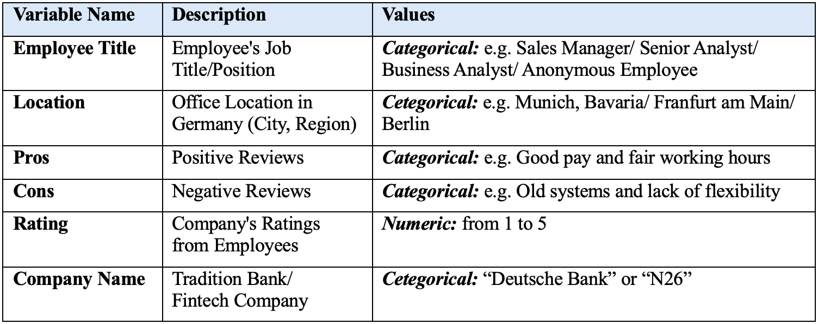

***Figure 1:*** *Showing the data frame “db” (Deutsche Bank) and “n26” (N26)*

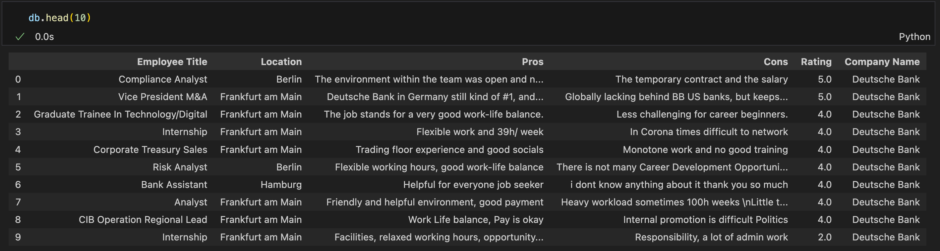

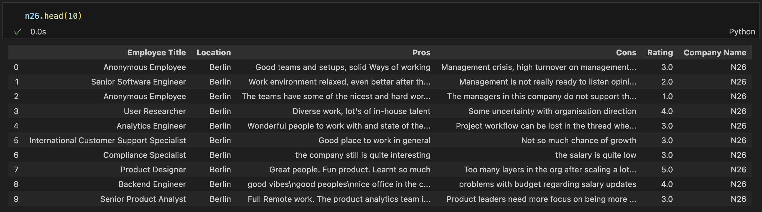

After creating two data frames, I checked each dataset to identify missing values. From the output, it is noticeable that **both DataFrames have none of the missing values in any column.**

1. **Descriptive Statistics**

**4.1 Exploratory Data Analysis (EDA)**

***(1) Work Location***

First, I would like to compare **the distribution of office locations by the number of employees for Deutsche Bank and N26**, respectively, by creating a bar graph for each company.

***Figure 2:*** *The distribution of office locations across Germany between Deutsche Bank and N26*

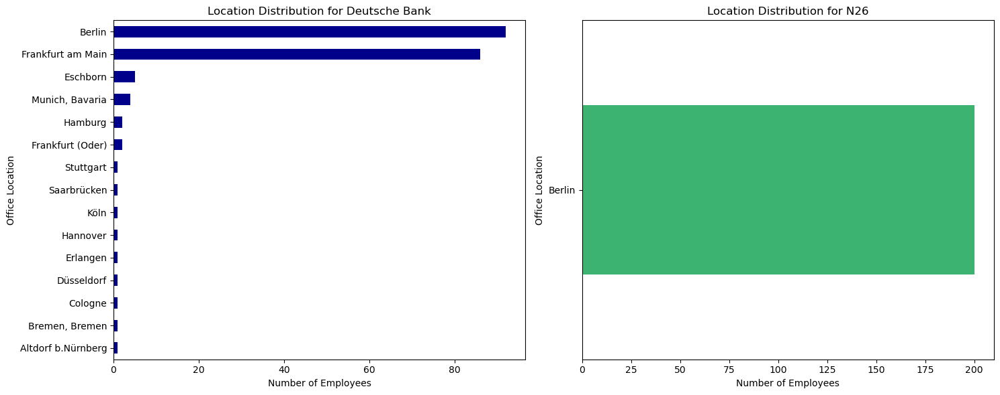

On the left, **the Deutsche Bank has broader office locations throughout Germany**, with *Berlin having the highest number of employees*. Frankfurt am Main also has significant numbers of employees but fewer than Berlin. Meanwhile, **N26 appears to be highly centralized in Berlin.**

***(2) Employee Job Title/Position***

Secondly, I used pie charts to represent **the top 10 employee job titles/positions at Deutsche Bank and N26**.

***Figure 3:*** *The distribution of office locations across Germany between Deutsche Bank and N26*

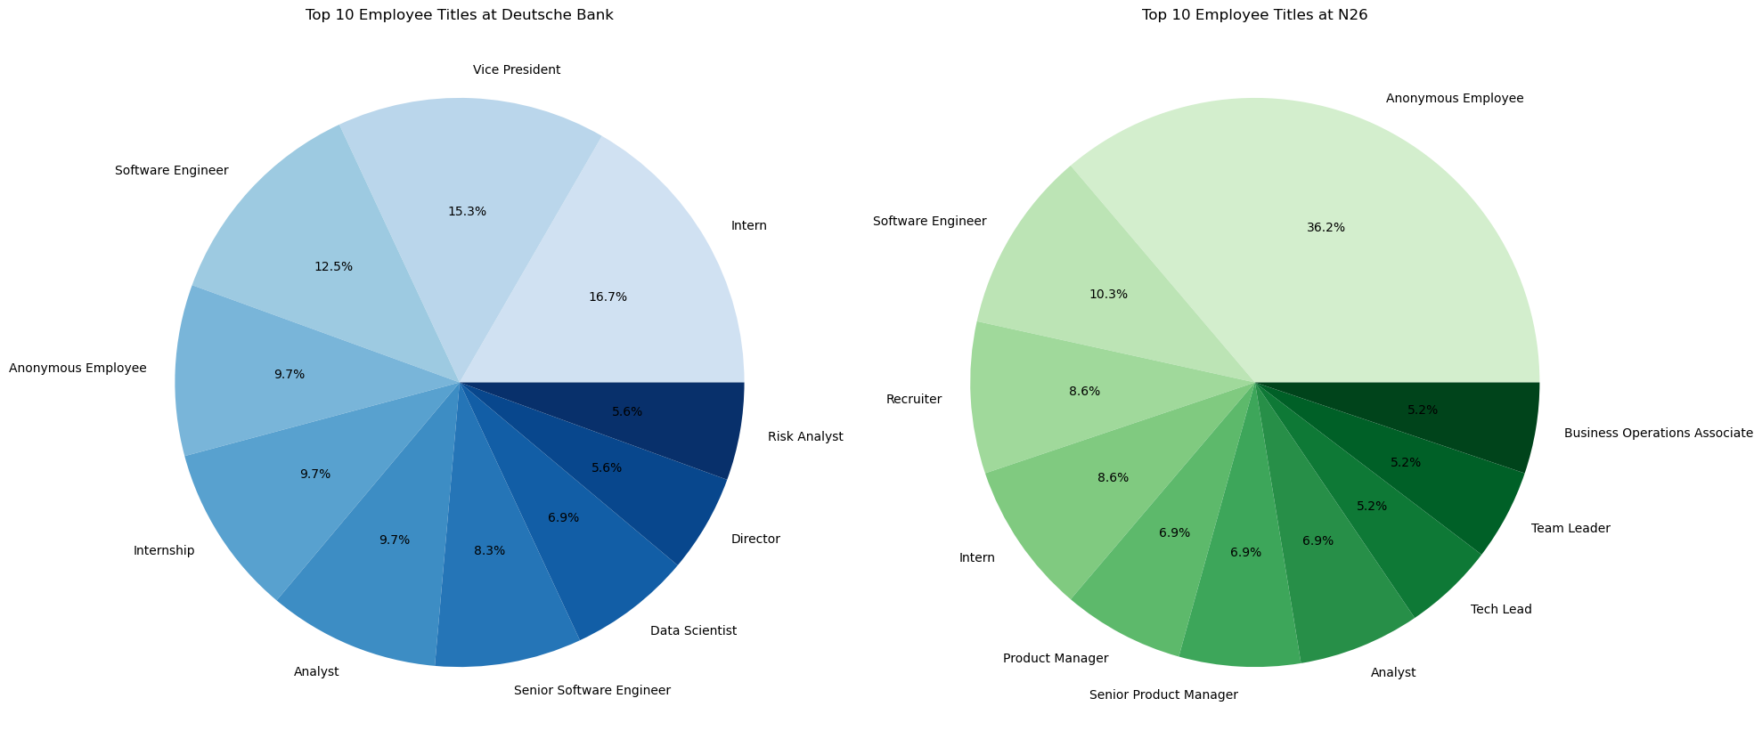

For Deutsche Bank, the largest segment is ***'Intern'***, making up *16.7% of the top positions* and the second largest is ***'Vice President'***, with *15.3%.* Additionally, ***'Software Engineer'*** and ***'Anonymous Employee'*** account for 12.5% and *9.7%*, respectively.

For N26, ***'Anonymous Employee'*** dominates the chart with a significant *36.2%* and ***'Software Engineer'*** is also notable at *10.3%.* In addition,***'Recruiter'*** *and* ***‘Intern’***follow the same proportion, for *8.6%.*

***(3) Distribution of the Ratings***

For the *Rating* column, I create two bar charts to display **the distribution of ratings for Deutsche Bank and N26**.

***Figure 4:*** *The distribution of the ratings between Deutsche Bank and N26*

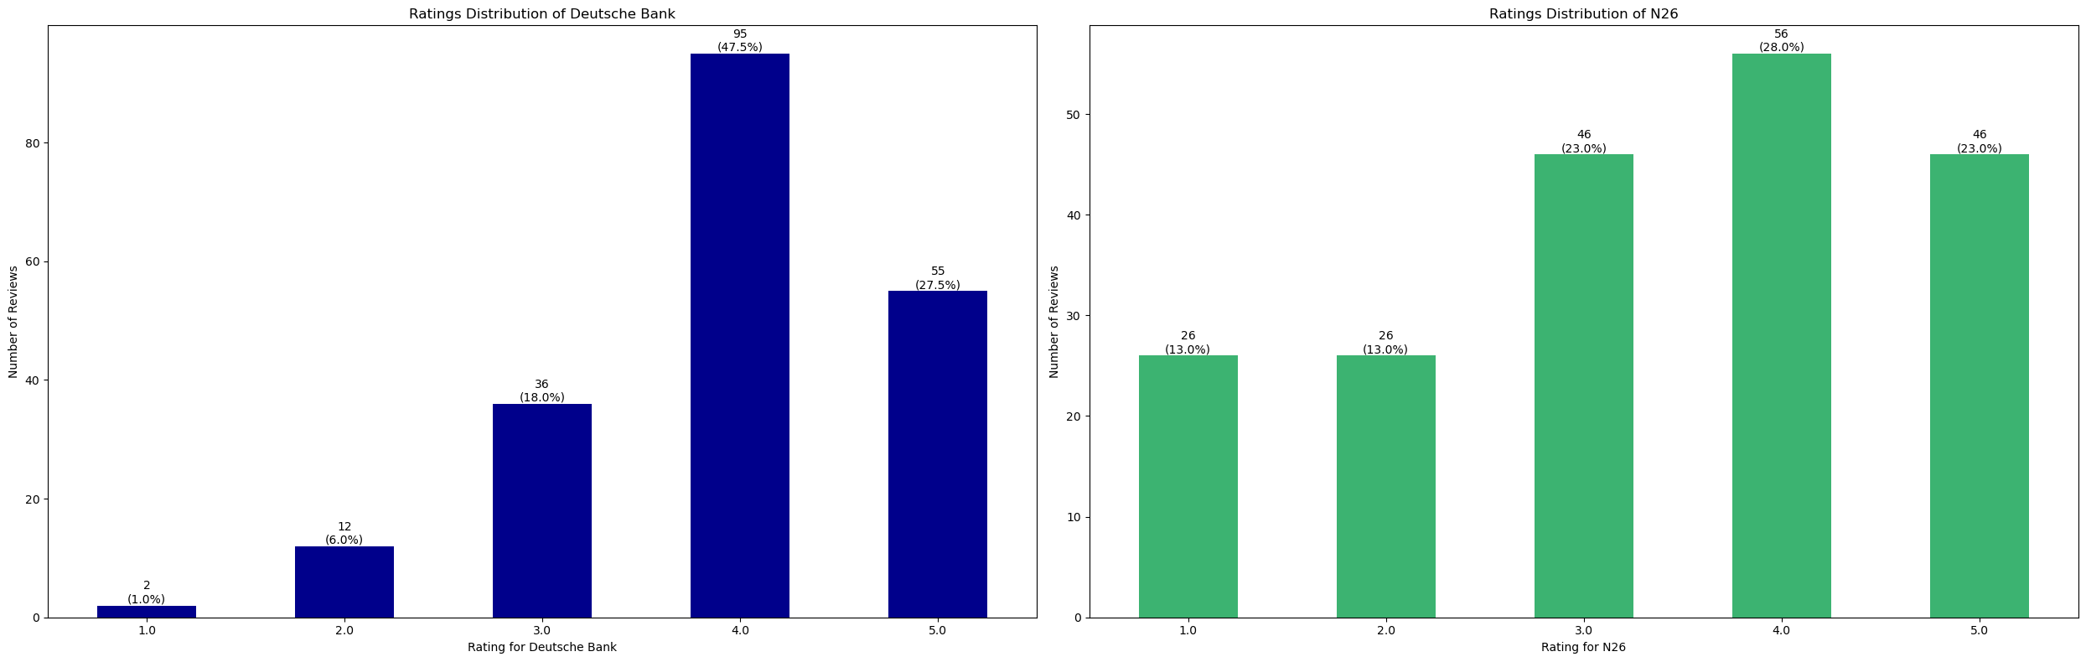

For Deutsche Bank, the chart shows that the majority of reviews are very positive, with 95 (~47.5%) and 55 reviews (~27.5%) at a 4 and 5-star rating, respectively. Meanwhile, *the most common rating of N26 is 4 stars, with 28% or 56 reviews.* Both 5-star and 3-star ratings have 46 reviews or 23% each. Interestingly, both companies have **a higher concentration of 4-star and 5-star ratings**, *indicating generally positive feedback.*

**4.2 Text Exploratory Before Preprocessing Steps**

Before preprocessing, I calculated ***the total word count, the average length of reviews, and the average word length*** in the ***'Pros'*** and ***'Cons'*** reviews for Deutsche Bank and N26.

***Table 2:*** *Key findings for text exploratory section before preprocessing steps*

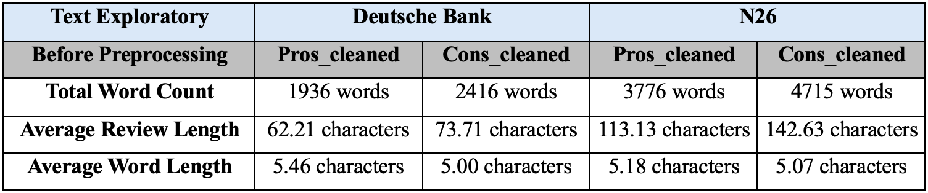

In this step, I identified ***the top 10 most common words*** in the ***‘Pros’***and ***‘Cons’*** reviews for both datasets before preprocessing.

***Figure 5:*** *Top 10 most common words and their frequencies for the positive (‘Pros’) and negative (‘Cons’) reviews of Deutsche Bank and N26 before preprocessing*

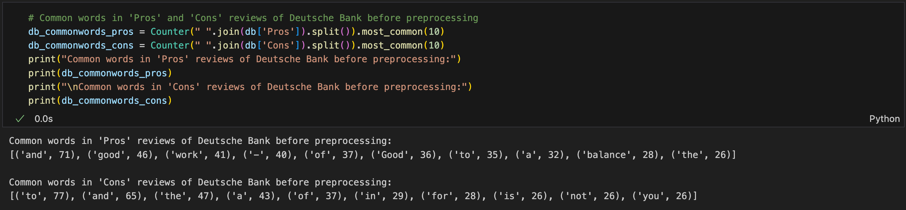

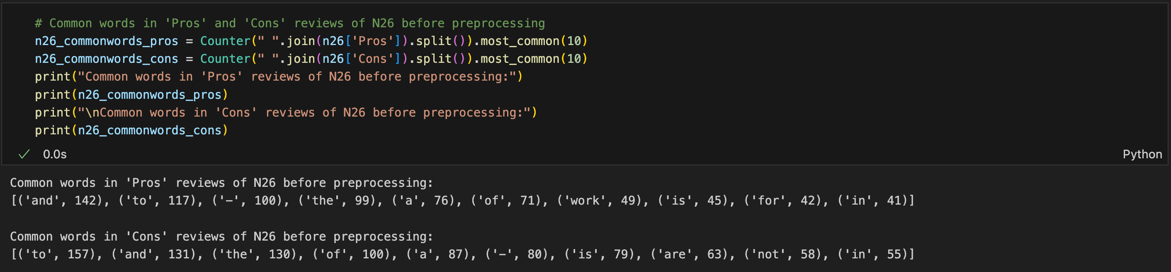

Then, I performed ***a linguistic analysis of the text data by tokenization, POS tagging, and Named Entity Recognition (NER),*** helping to understand the grammatical structure, identify important words and phrases, and recognize named entities before the preprocessing steps.

**4.3 Preprocessing Steps for Text Analysis**

At this stage, I performed **text preprocessing on the “Pros” and “Cons” reviews for both datasets**. Then, I defined a preprocessing function called ***preprocess_text***, which applies several transformations to the text by *converting text to lowercase, removing numbers and punctuation, removing hyphens and replace with space, replacing multiple whitespaces with a single space, and striping any leading/trailing whitespace*. After that, I used *spaCy for tokenization and stop word removal which filters out tokens that are stop words, punctuation, whitespace, single characters, numeric-like tokens, and currency symbols*. Lastly, I also *excluded pronouns and then joined the tokens back into a string to form cleaned text*.

The function is then applied to the “Pros” and “Cons” columns of both datasets, and the cleaned text is stored in new columns ***“Pros_cleaned”*** and ***“Cons_cleaned”*** for further analysis.

***Figure 6:*** *Storing cleaned text in Pros_cleaned and Cons_cleaned columns for both datasets*

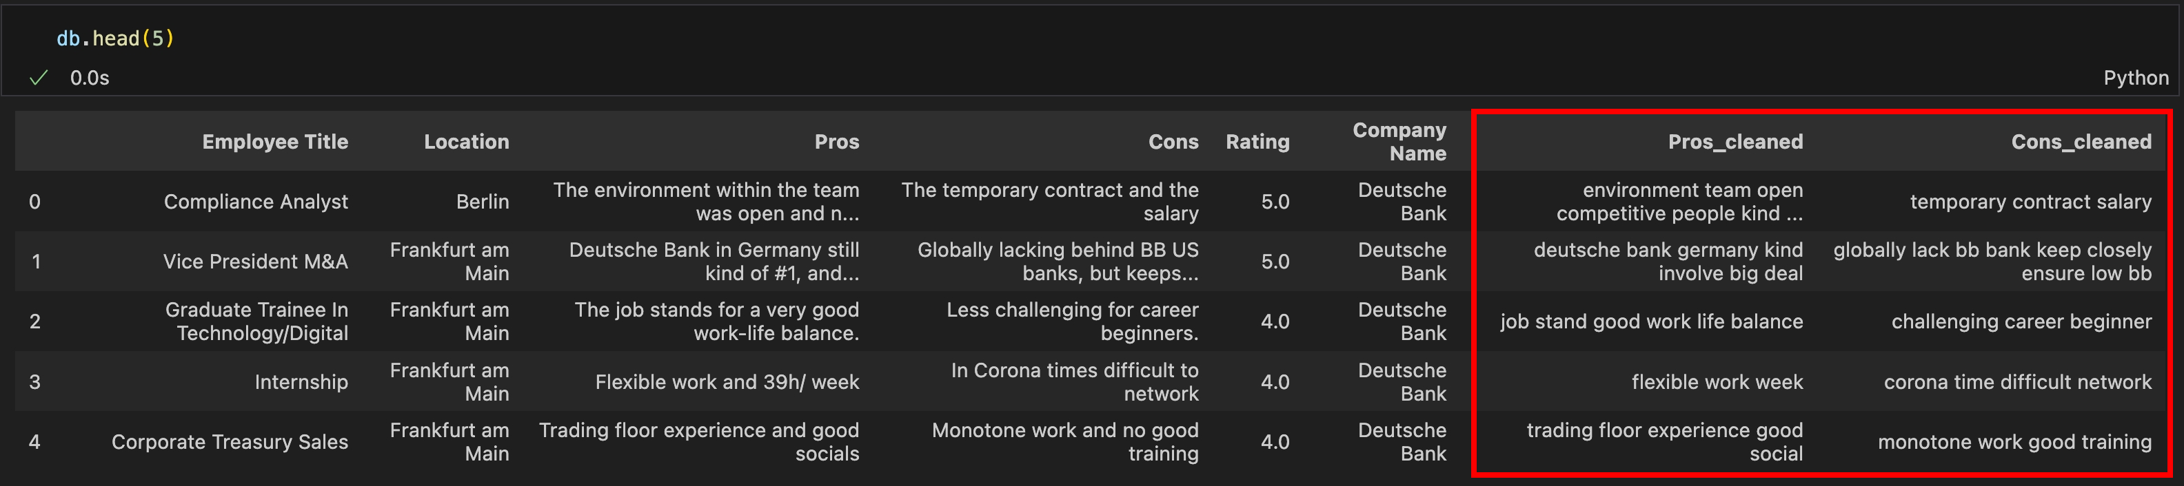

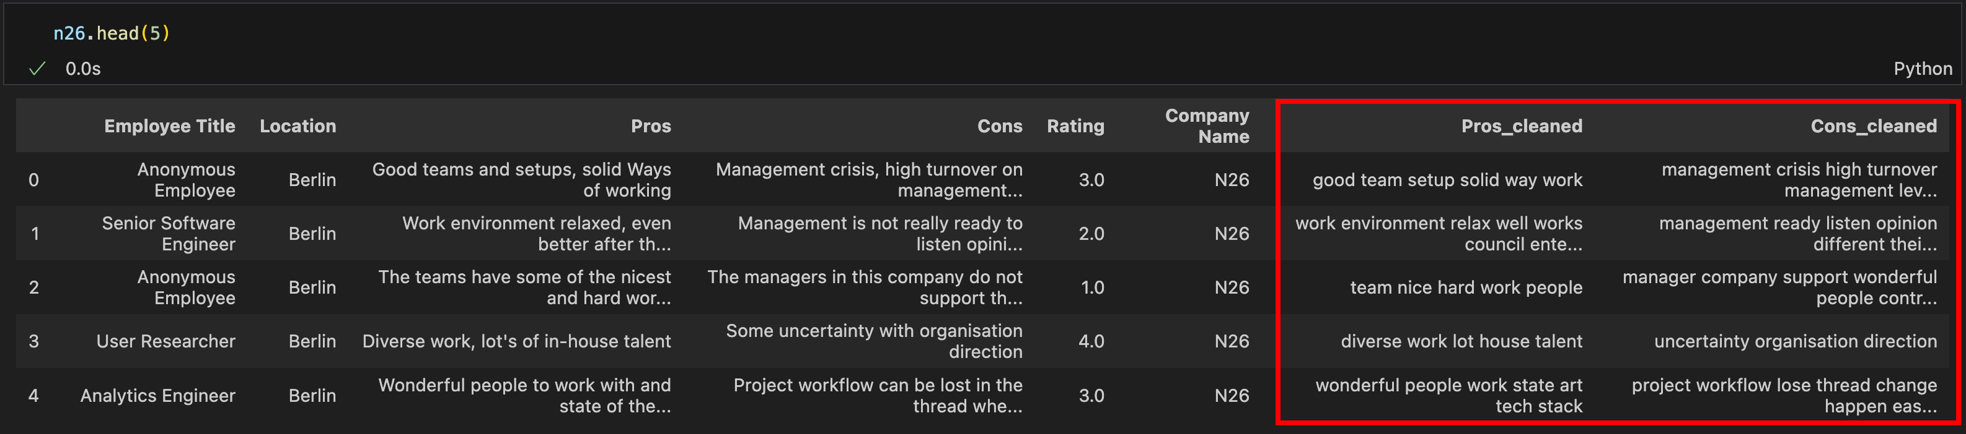

1. **Main Analysis, Methodology**

**5.1 Text Exploratory After Preprocessing Steps**

After preprocessing, I calculated ***the total word count, the average length of reviews, and the average word length***in the ***“Pros_cleaned”*** and ***“Cons_cleaned”*** reviews for both companies.

***Table 3:*** *Key findings for text exploratory section after preprocessing steps*

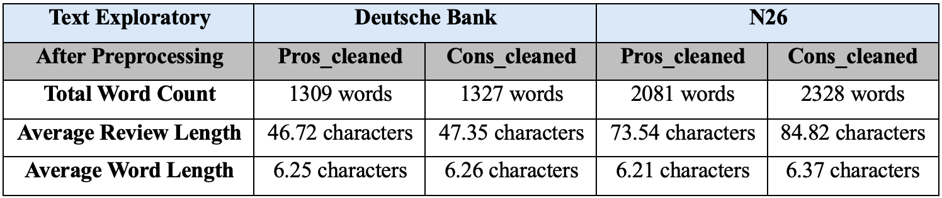

Then, I generated **word clouds for the *“Pros_cleaned”* and *“Cons_cleaned”* of both datasets** to represent the most frequent words in the positive and negative reviews, providing a quick overview of the sentiments expressed by employees towards each company.

***Figure 7:*** *Word clouds for ‘Pros_cleaned’ and ‘Cons_cleaned’ reviews of both companies*

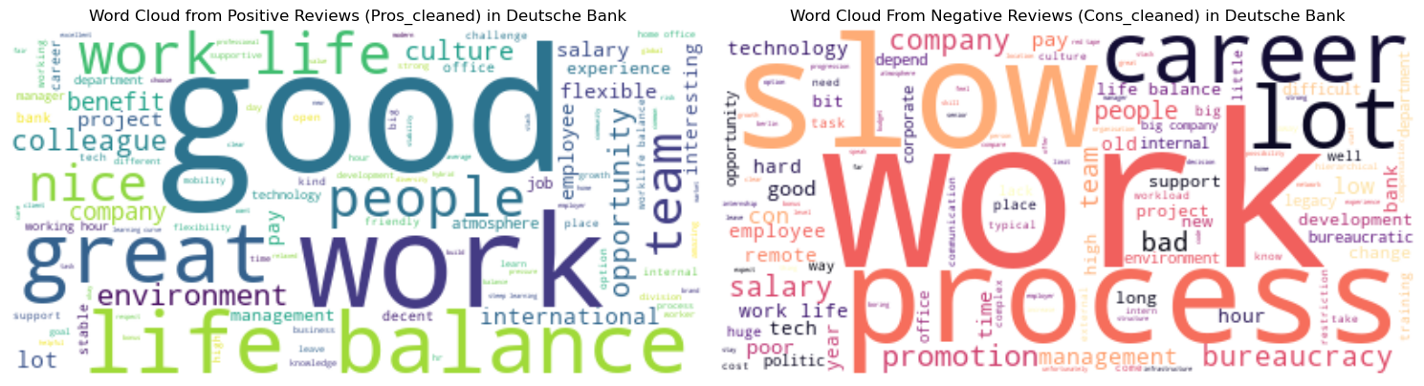

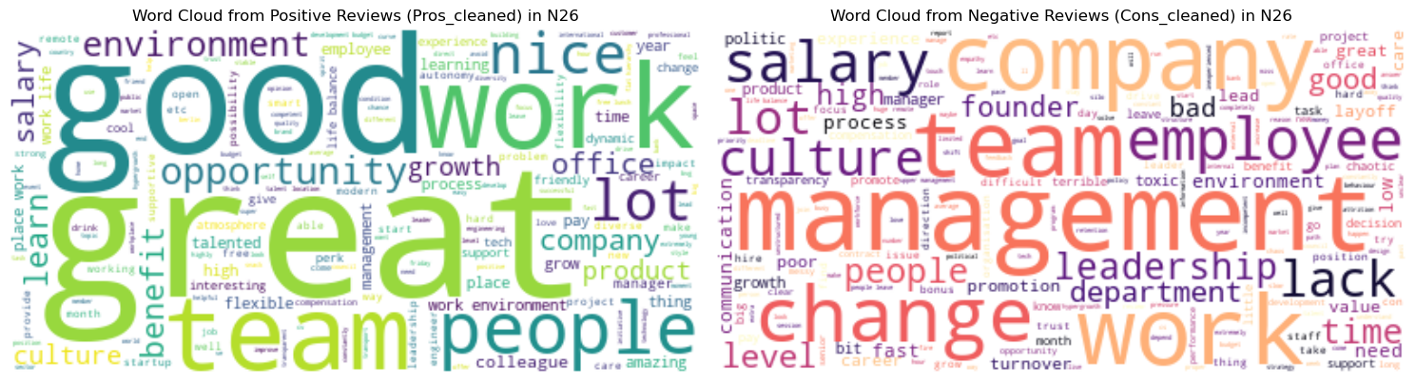

Overall, both companies show positive feedback on the **“team”** and **“people”**. Noticeably, **“work-life balance”** is prominent in the positive aspects of Deutsche Bank, while **“slow work process**” and **"management"** are negative points for Deutsche Bank and N26, respectively.

Next, I created bar charts of **the most common words found in the positive and negative reviews of Deutsche Bank and N26** to provide concise common themes in employee feedback.

***Figure 8:*** *Top 10 common words in the “Pros_cleaned” and “Cons_cleaned” of both datasets*

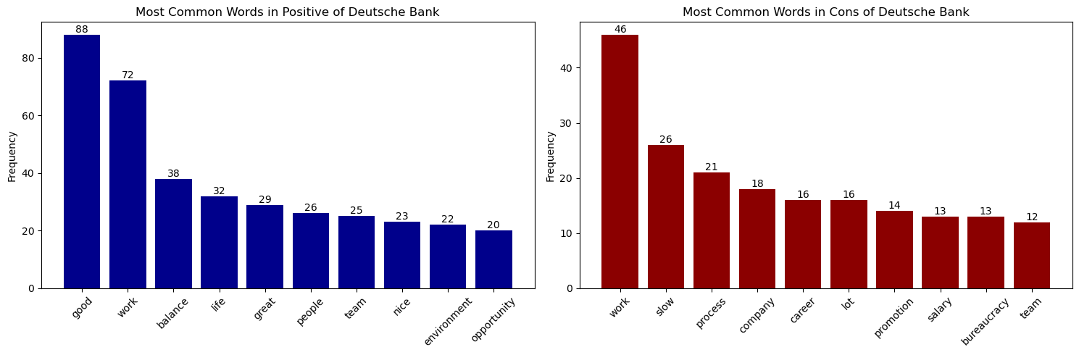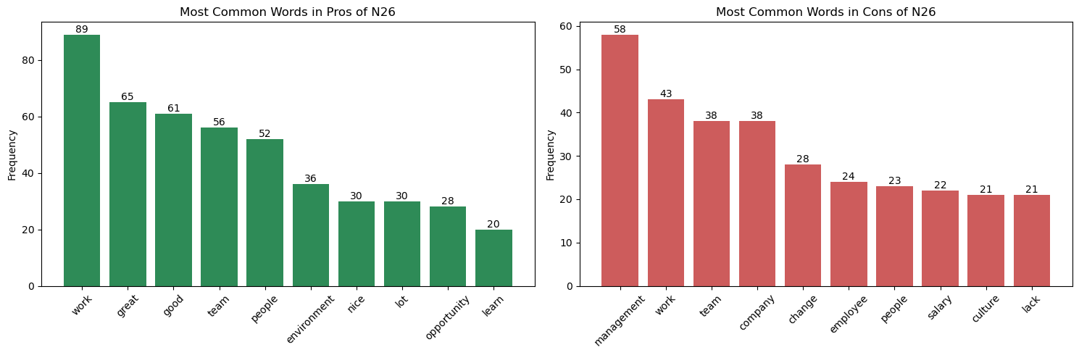

*N26’s positive reviews* most frequently include **“work” (89), “great” (65), “good” (61), and “tea” (56),** indicating that *employees have a positive perception of their work, team, and the overall company culture.* Meanwhile, *negative reviews* related to **“management” (58)** are the most cited issue, followed by **“work” (43), “team” (38), and “company” (28)**, pointing towards *concerns primarily related to management and team dynamics.*

**5.2 Topic Modeling**

For a topic modeling analysis, I applied **Latent Dirichlet Allocation (LDA)** to positive ***(‘Pros_cleaned’)*** and negative ***(‘Cons_cleaned’)*** employee reviews of Deutsche Bank and N26 to identify **common themes of both companies.**

***Figure 9:*** *The LDA analysis on employee reviews of both companies for topic modeling*

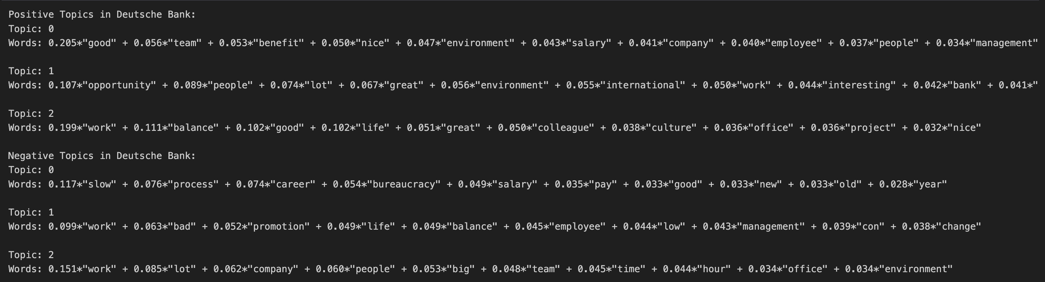

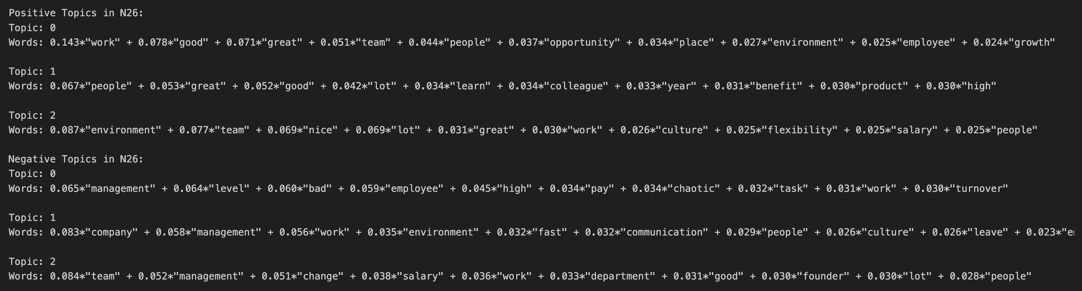

In summary, Deutsche Bank’s employees value teamwork, benefits, the international work environment, and work-life balance, but they express concerns about slow career progression, bureaucratic management, heavy workload, and complexities of large company structures.

Conversely, N26's employees appreciate teamwork, the work environment, and compensation schemes, yet they voice concerns about management practices, organizational structure, rapid company changes, cultural dynamics, and communication deficiencies.

**5.3 Clustering Classification**

***(1) Clustering Positive Reviews about Working in Deutsche Bank***

In this step, I applied **text clustering** on the “Pros_cleaned” from the “db” dataset, using ***the TF-IDF (Term Frequency-Inverse Document Frequency)*** *and* ***‘CountVectorizer’*** *or* ***the Bag-of-Words (BoW) representations***with a ***‘ngram_*range’** *covering single words, bigrams, and trigrams.* **The KMeans clustering algorithm** was then employed to group the textual data into distinct clusters based on their semantic similarities.

***Figure 10:*** *Text clustering on ‘Pros_cleaned’ from ‘db’ dataset by using TF-IDF and BoW*

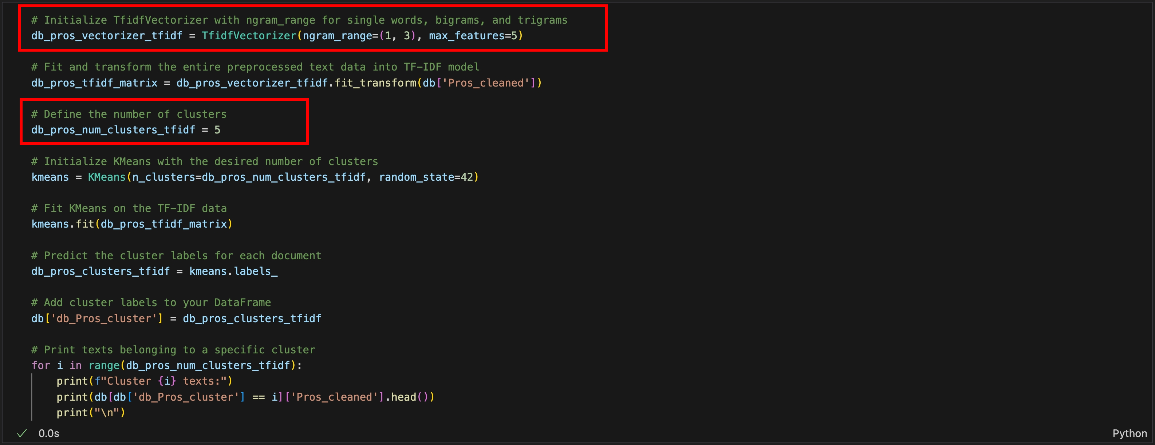

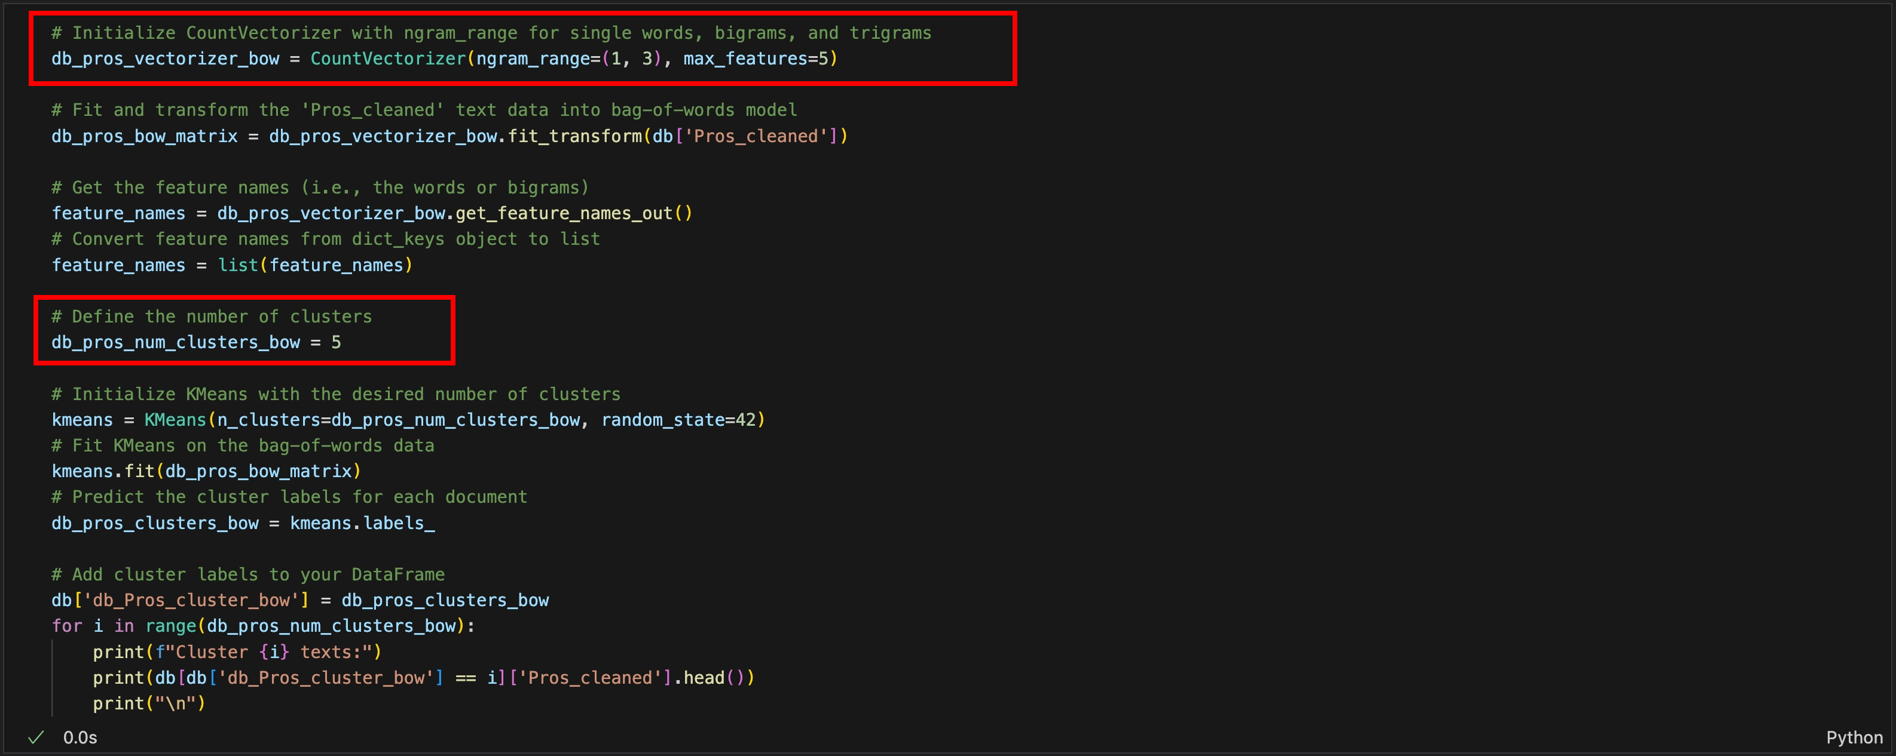

Then, I applied **the elbow method** *to find the optimal number of clusters,* for two different text data vectorizations: ***TFIDF (blue line) and BoW (green line).***

***Figure 11:*** *The elbow method for the TF-IDF and BoW of Deutsche Bank’s positive reviews*

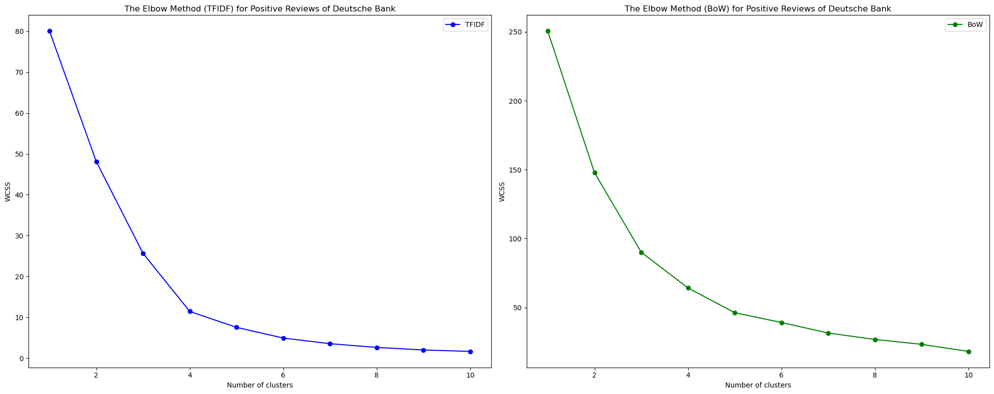

Both graphs show that ***the optimal number of clusters is 5 as a suitable choice for both vectorization methods (TFIDF and BoW)***, indicating that increasing the number of clusters beyond 5 will not yield significantly more distinguished.

To compare the effectiveness of these two approaches (TF-IDF and BoW) in clustering the text data*,* I calculated **silhouette scores** for each representation. The silhouette scores provide insights into ***the quality of clustering achieved with each representation.*** The silhouette score ranges from -1 to 1, where a score closer to 1 indicates that the object is well-clustered, a score around 0 indicates overlapping clusters and a negative score indicates that the object may be assigned to the wrong cluster.

***Figure 12:*** *The silhouette score for the TF-IDF and BoW of Deutsche Bank’s positive reviews*

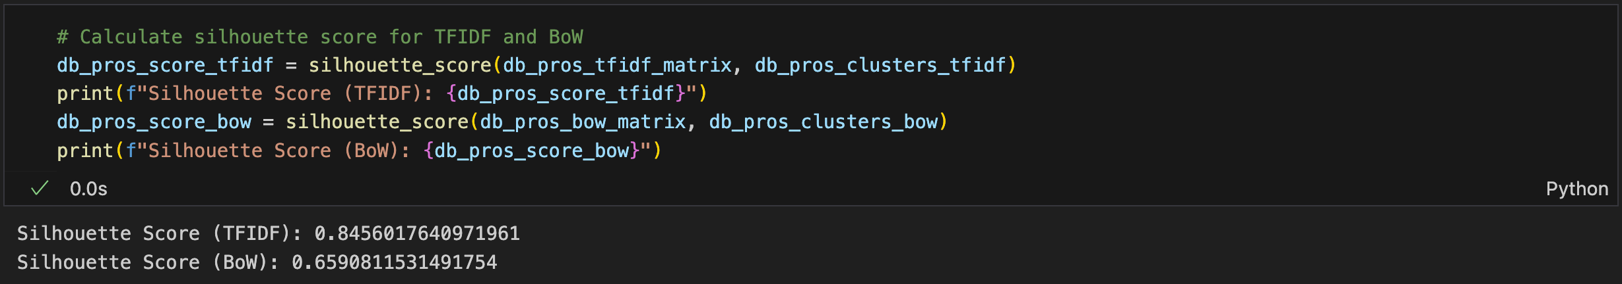

Based on the results shown, higher silhouette scores generally indicate better clustering quality, suggesting that **the TF-IDF representation**, *with a score of ~0.85,* may have led to ***more distinct and well-separated clusters*** compared to **the BoW representation**, *with a score of ~0.66.*

After that, I generated **word clouds** for each cluster in the dataset with the TF-IDF and BoW representations of the ‘Pros_cleaned’ data to ***represent key themes and topics within each cluster,*** *offering insights into employees’ feedback for organizational improvements.*

***Figure 13:*** *Word clouds for each cluster of Deutsche Bank’s Pros_cleaned with TF-IDF and BoW*

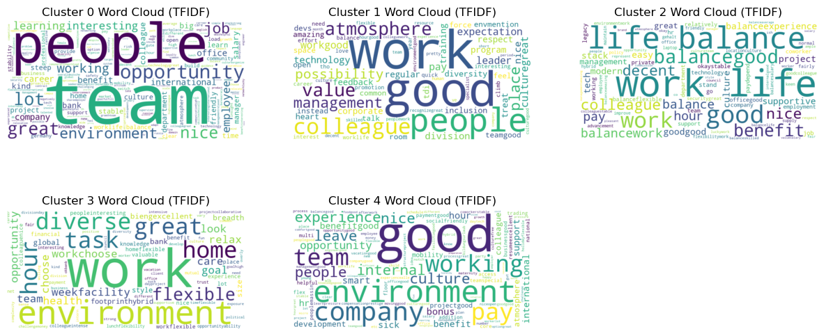

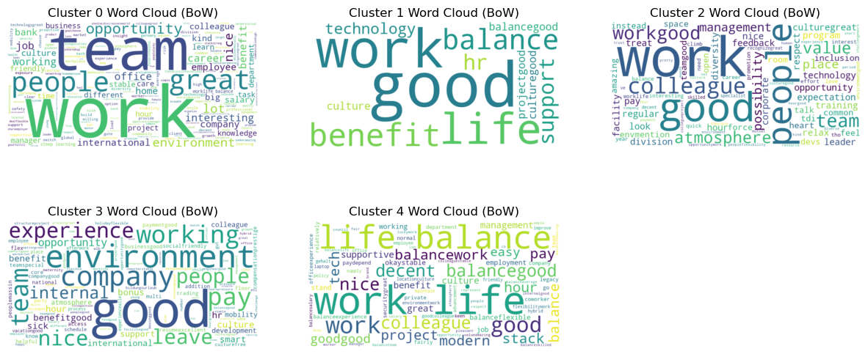

In these word clouds using BoW, it is noticeable thatthere are some**overlapping topics** such as ***work-life balance in clusters 1 and 4.*** Therefore, I could safely say that ***the BoW approach in this case does not show the uniqueness of the text data as strong as the TF-IDF.***

After text clustering using both vectorizations, checking the optimal number of clusters with elbow method and silhouette scores, including generating a series of word clouds, it appears that ***TF-IDF vectorization is better at capturing the nuances and uniqueness of the text data,*** which is particularly useful in sentiment analysis. **Therefore, I use TF-IDF vectorization for the subsequent sentiment analysis of the remaining job reviews.** Then, I generated **summaries for each cluster**, highlighting *the key values expressed in the positive reviews of Deutsche Bank.*

***Figure 14:*** *The dominant themes within each cluster of the Deutsche Bank’s positive reviews*

**

Then, I created a visualization to **show the distribution of positive comments at Deutsche Bank across different clusters.**

***Figure 15:*** *The distribution of positive comments at Deutsche Bank across different clusters.*

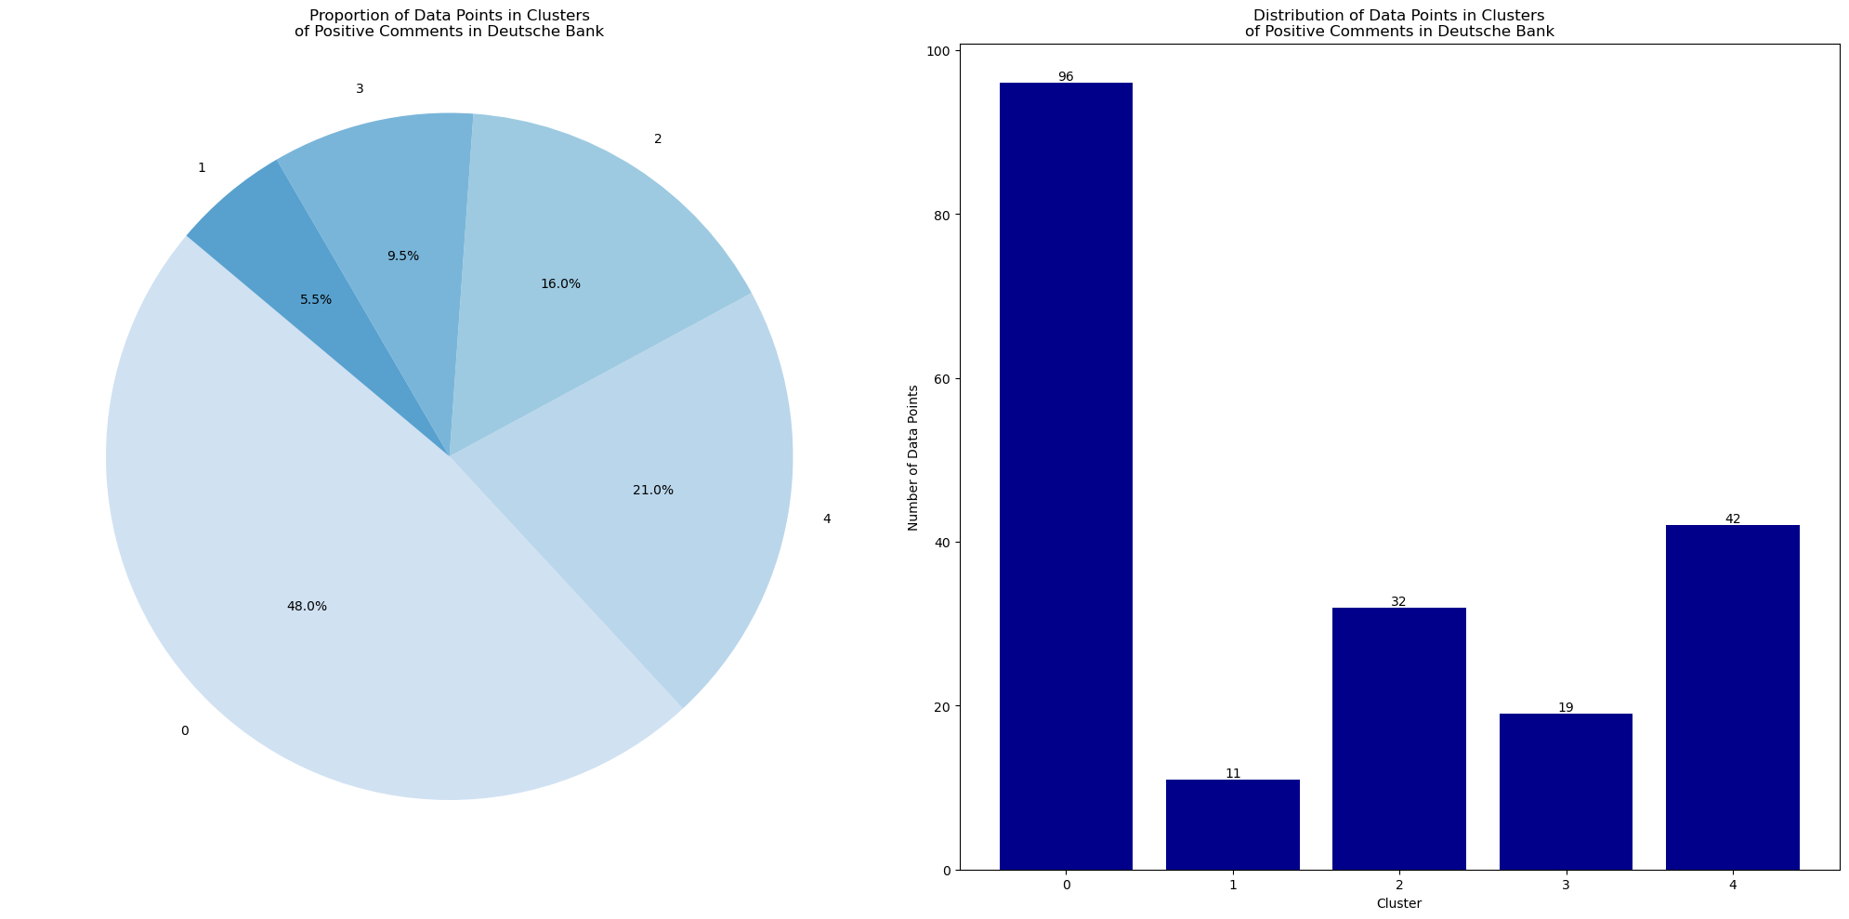

This visual analysis shows that **cluster 0 holds the majority with 48% or 96 comments,**implying that *employees appreciate teamwork and work opportunities the most.***Clusters 2 and 4 have a substantial amount of comments, with 32 (16%) and 42 (21%),** respectively, reflecting that *employees have work-life balance and good working experiences.*

***(2) Clustering Negative Reviews about Working in Deutsche Bank***

I performed text clustering on the “Cons_cleaned” from the “db” dataset using the same methods as beforeto show *the key themes of the negative reviews from Deutsche Bank’s employees.*

***Figure 16:*** *Text clustering on ‘Cons_cleaned’ from ‘db’ dataset with TF-IDF*

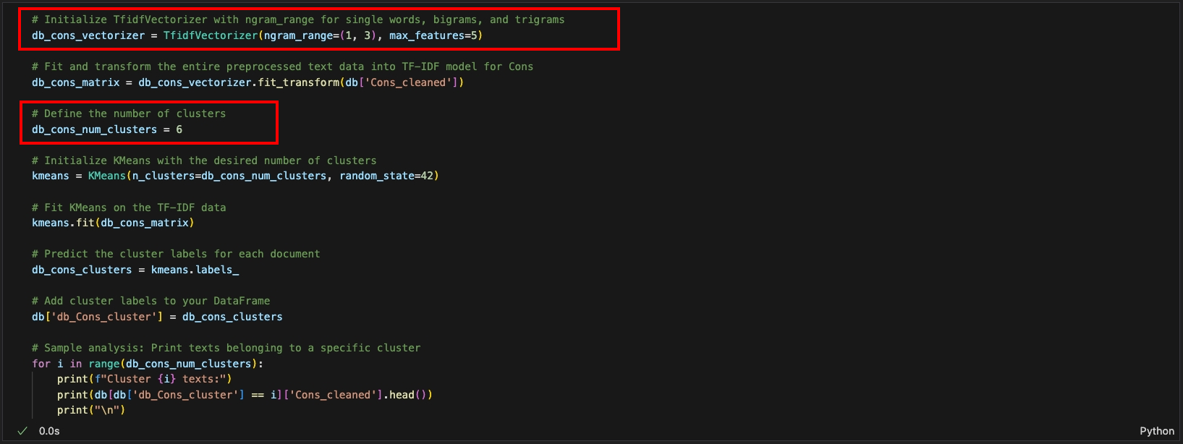

***Figure 17:*** *Elbow method and silhouette score for the TF-IDF of Deutsche Bank’s negative reviews*

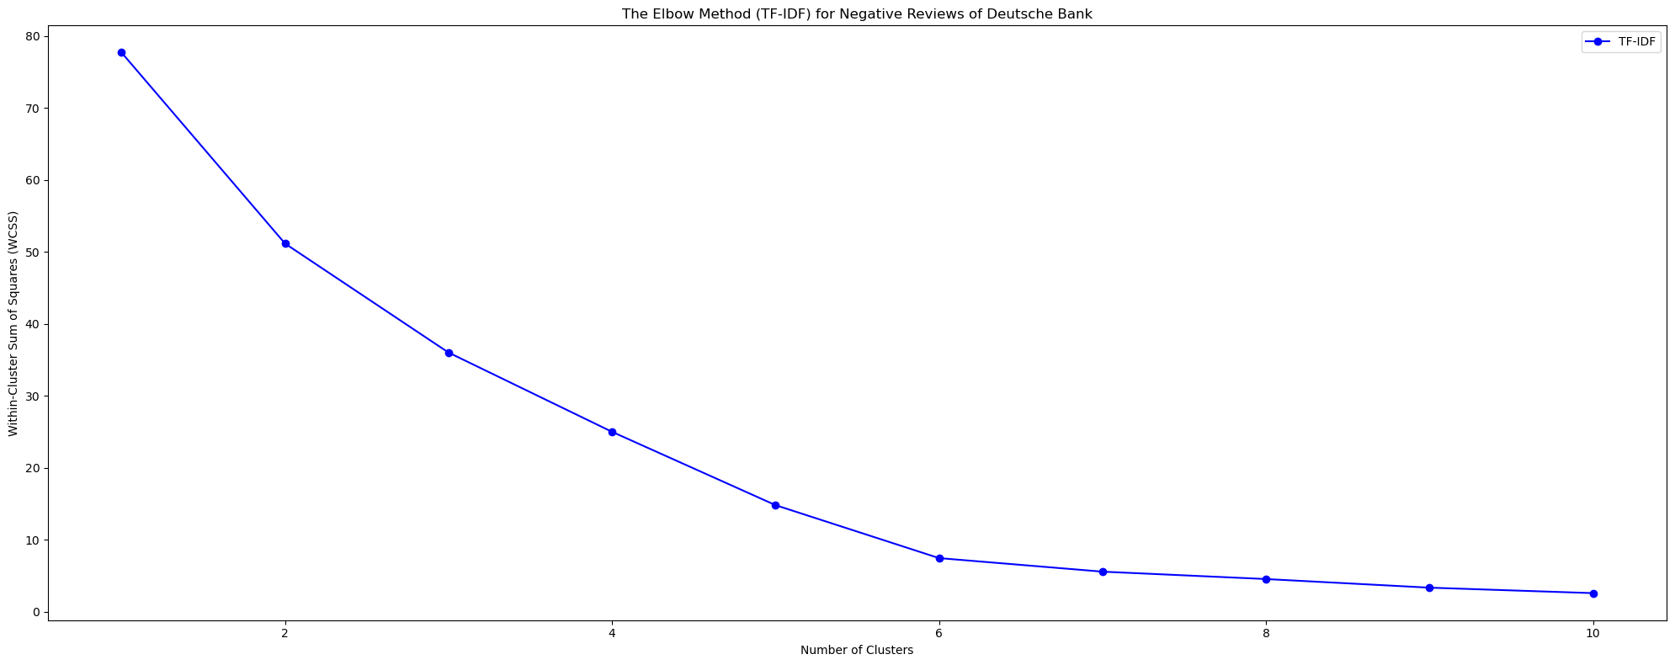

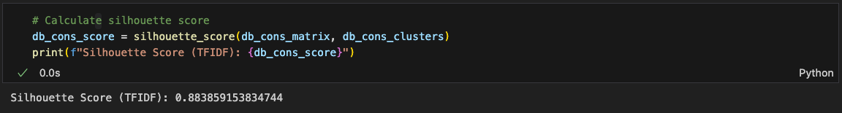

Based on the elbow method and silhouette score analysis, I selected ***6 clusters to categorize the negative reviews of Deutsche Bank,*** achieving *a silhouette score of approximately 0.88.*

Then, I created **word clouds** **and top-5-word summaries of each cluster** *to discover the prominent themes among the negative feedback from N26’s employees.*

***Figure 18:*** *Word clouds for each cluster of Deutsche Bank’s Cons_cleaned with TF-IDF*

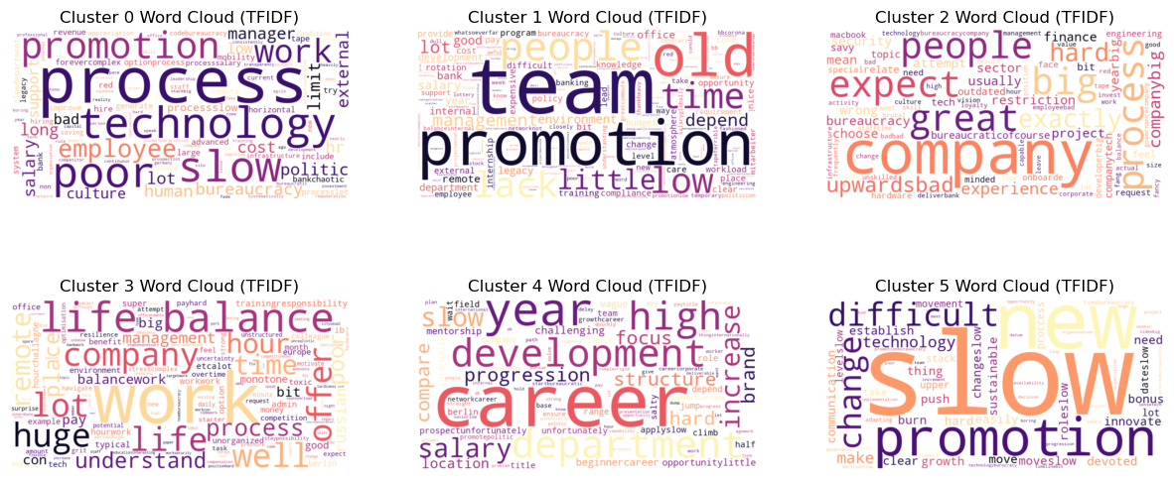

***Figure 19:*** *The dominant themes within each cluster of the Deutsche Bank’s negative reviews*

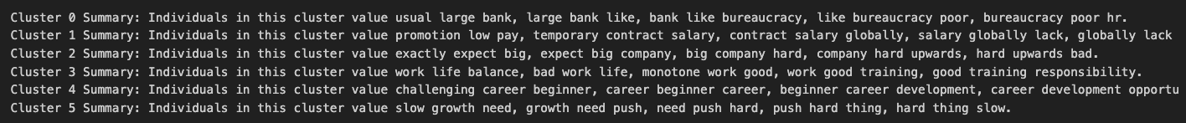

Then, I created the visualization below to illustrate the distribution of Deutsche Bank’s negative comments across various clusters.

***Figure 20:*** *The distribution of negative comments at Deutsche Bank across different clusters.*

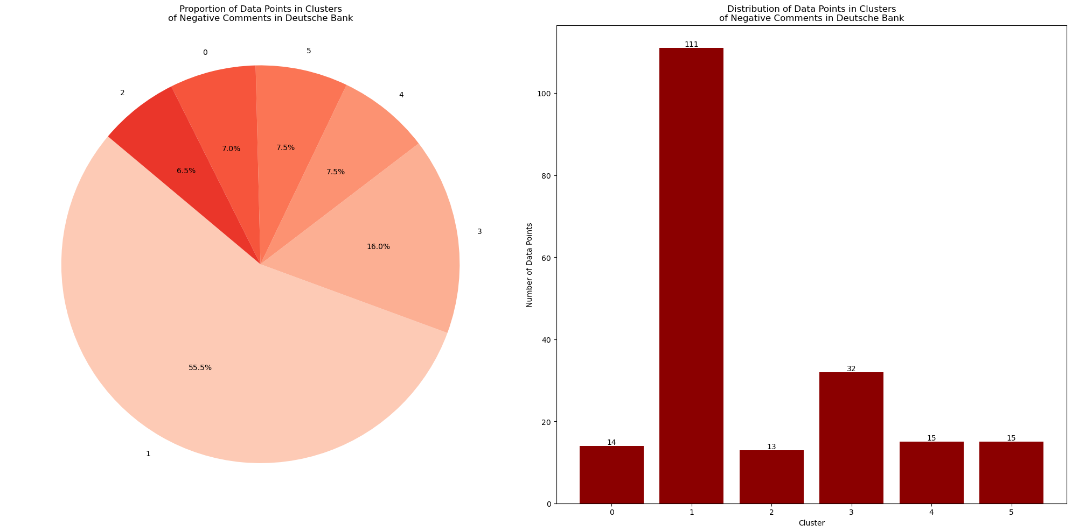

Noticeably, **cluster 1** emerges with the largest share, comprising **55.5% or 111 comments**, indicative of *prevalent concerns regarding low pay and a lack of promotion opportunities*. **Cluster 2** also exhibits a significant volume of comments, representing **16% or 32 comments**, highlighting *work-life balance as another prominent theme of dissatisfaction.*

***(3) Clustering Positive Reviews about Working in N26***

To pinpoint the main themes in N26's positive reviews, I clustered the 'Pros_cleaned' data from the 'n26' dataset by refining the ngram range for better silhouette score and text uniqueness.

***Figure 21:*** *Text clustering on ‘Pros_cleaned’ from the ‘n26’ dataset with TF-IDF*

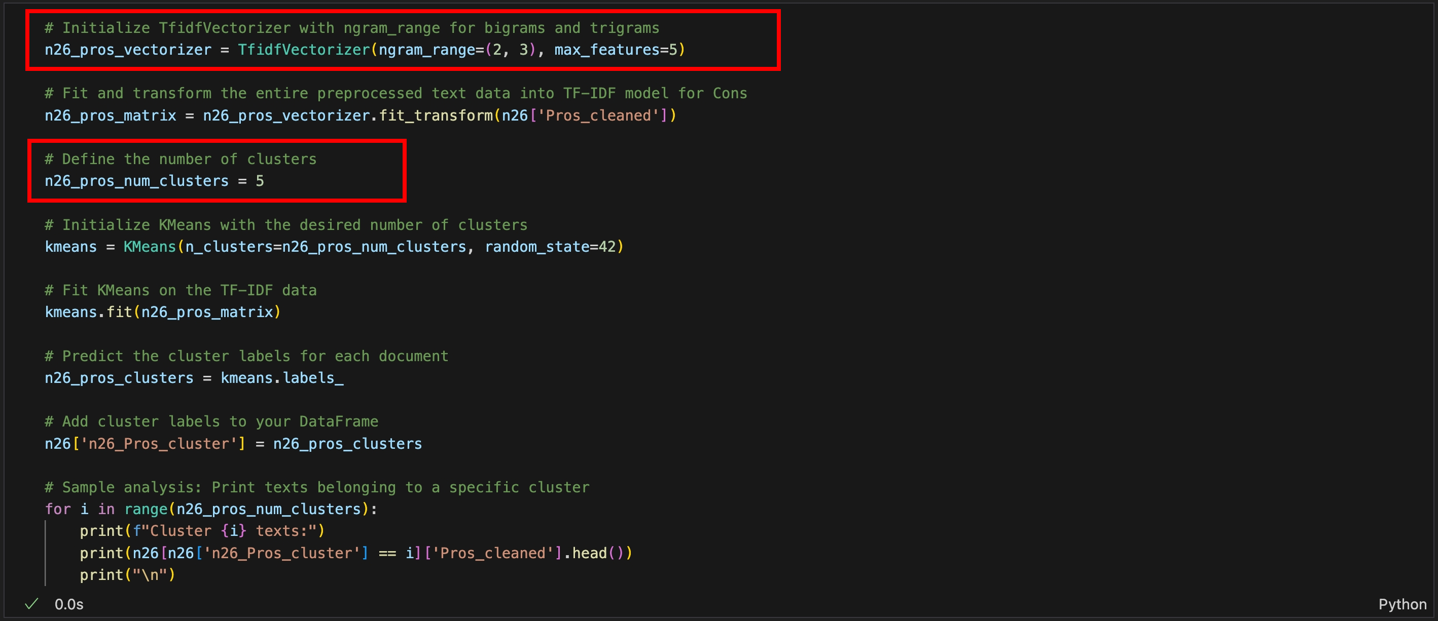

***Figure 22:*** *Elbow method and silhouette score for the TF-IDF of N26’s positive reviews*

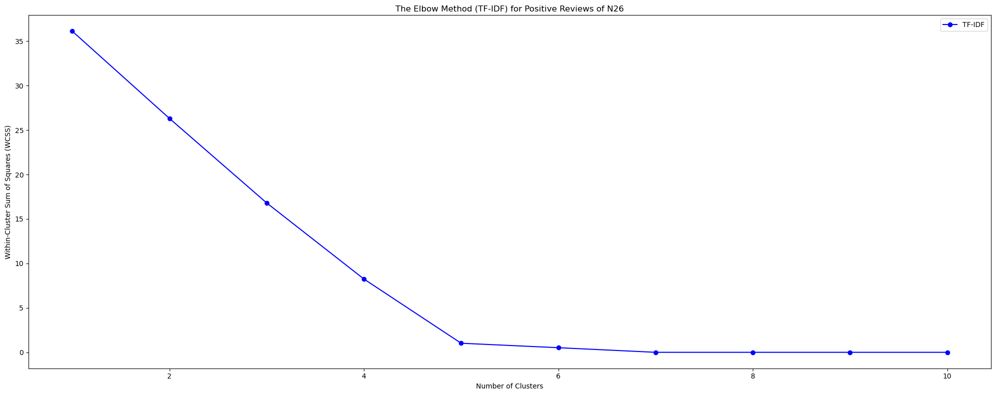

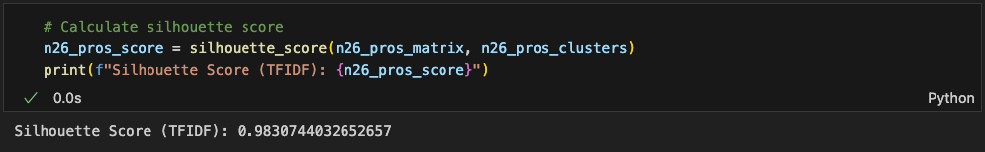

Based on the elbow method and silhouette score, **5 clusters are effective in categorizing the positive reviews of N26**, achieving *a silhouette score of approximately 0.98.*

Then, I created **word clouds** **and top-5-word summaries of each cluster** *to discover the prevalent topics emerging from the positive feedback from N26’s employees.*

***Figure 23:*** *Word clouds for each cluster of N26’s Pros_cleaned with TF-IDF*

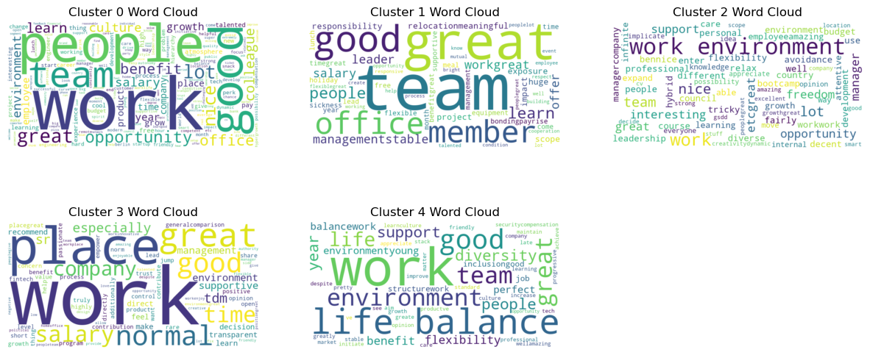

***Figure 24:*** *The dominant themes within each cluster of the N26’s positive reviews*



Then, I created the visualization below to illustrate the distribution of N26’s negative comments across various clusters

***Figure 25:*** *The distribution of positive comments at N26 across different clusters.*

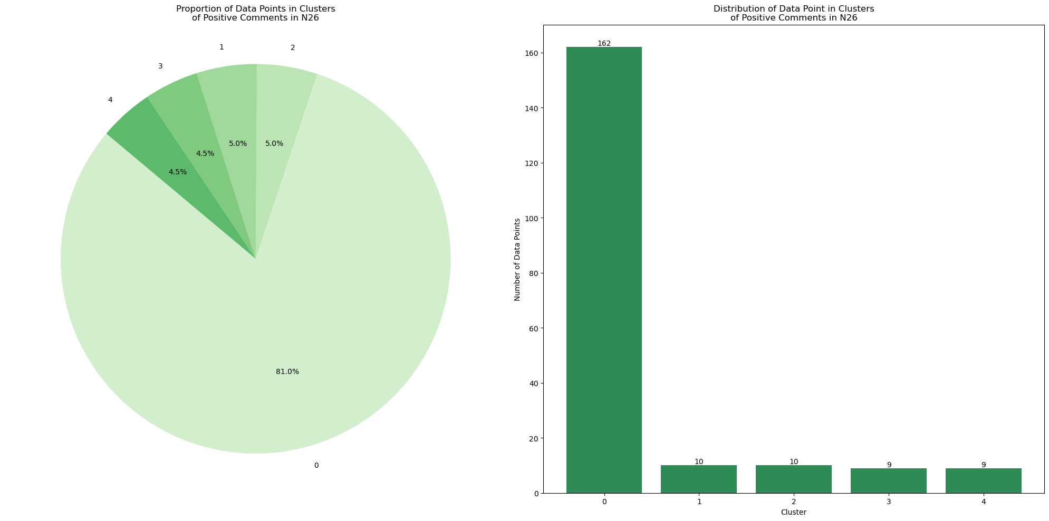

This visualization reveals that **cluster 0 is predominant with 81% or 162 comments,**indicating that *employees are satisfied with flexible team dynamics and opportunities for personal development the most.***Clusters 1 and 2 each account for 5% of the comments,** reflecting that *employees appreciate the strength of teamwork and a supportive and pleasant work environment****.***

***(4) Clustering Negative Reviews about Working in N26***

Lastly, I performed **text clustering** on the 'Cons_cleaned' data from the 'n26' dataset with similar methods as previously ***to find the main themes within N26's positive reviews.***

***Figure 26:*** *Text clustering on ‘Cons_cleaned’ from the ‘n26’ dataset with TF-IDF*

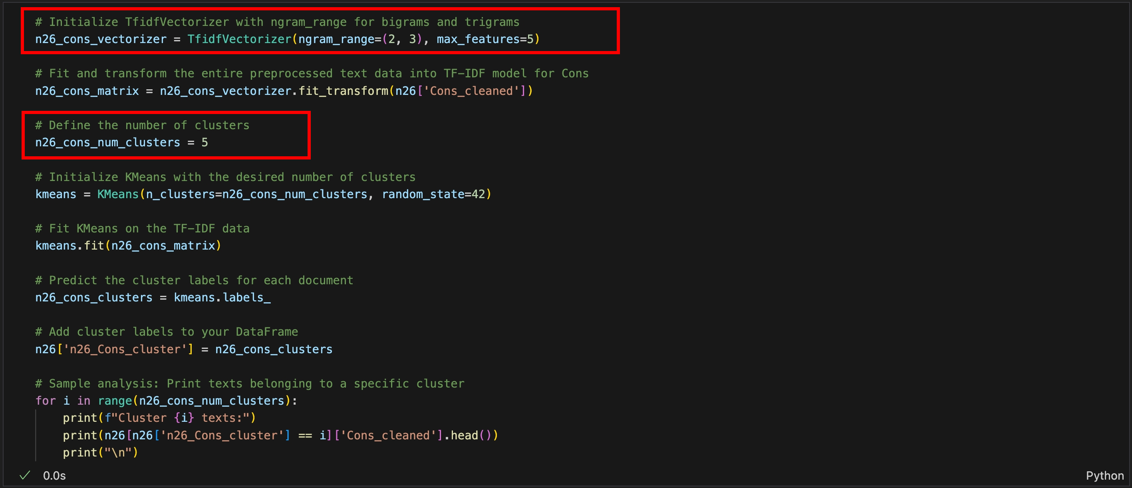

***Figure 27:*** *Elbow method and* silhouette score *for the TF-IDF of N26’s negative reviews*

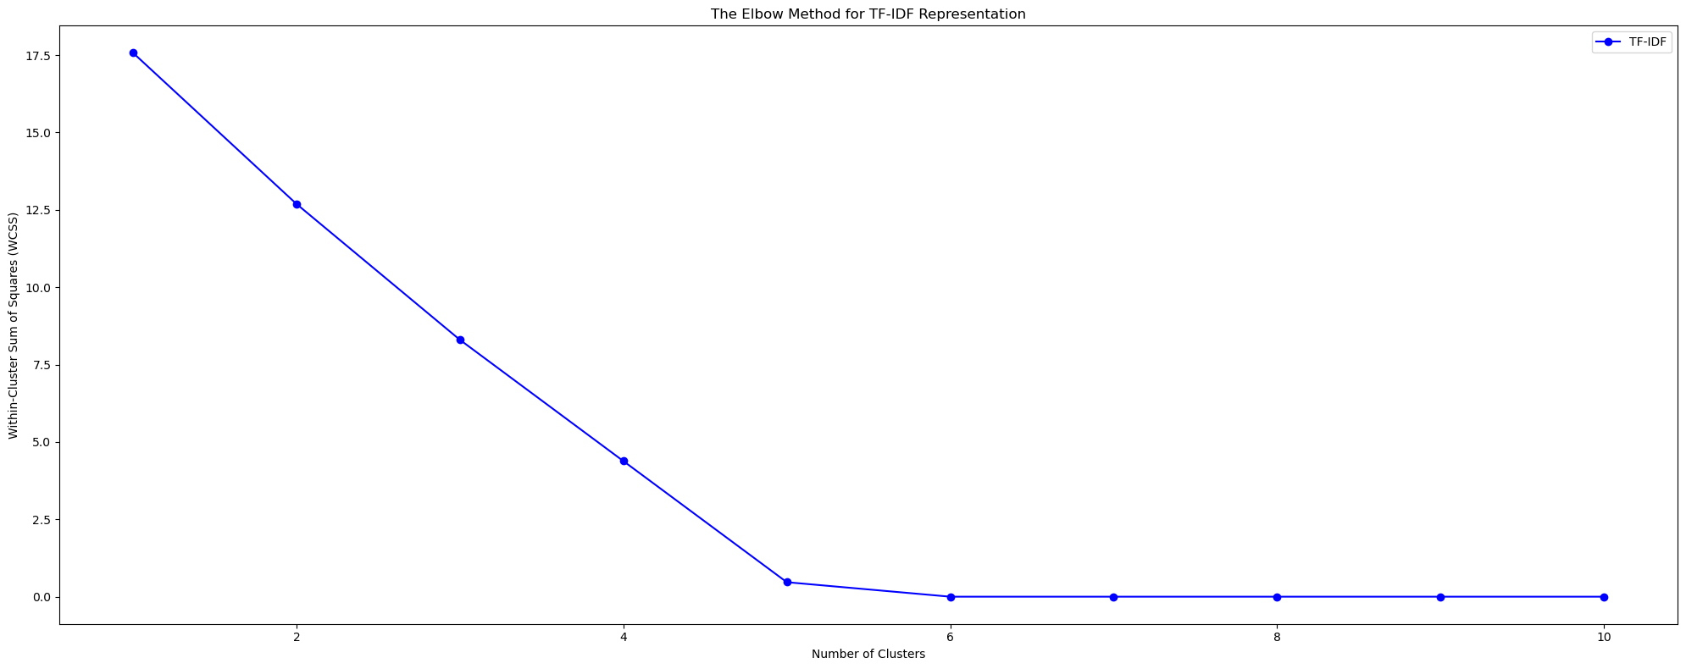

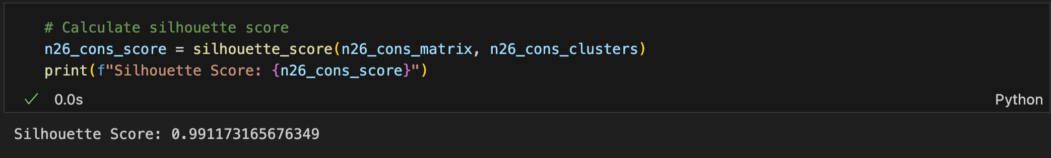

Regarding the elbow method and silhouette score, **5 clusters were determined as effective for categorizing the negative reviews of N26**, achieving *a silhouette score of approximately 0.99.*

Subsequently, I generated **word clouds** andsummarized **the top 5 words for each cluster** *to uncover prevalent topics within the negative feedback from N26’s employees.*

***Figure 28:*** *Word clouds for each cluster of N26’s Cons_cleaned with TF-IDF*

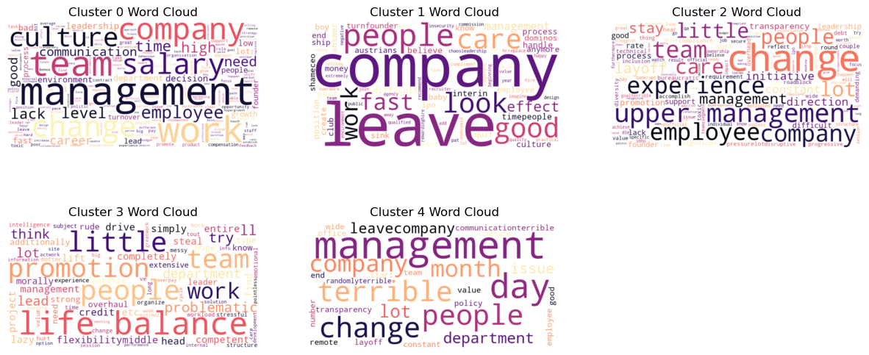

***Figure 29:*** *The dominant themes within each cluster of the N26’s positive reviews*



Then, I created the visualization as below to illustrate the distribution of N26’s negative comments across various clusters

***Figure 30:*** *The distribution of positive comments at N26 across different clusters.*

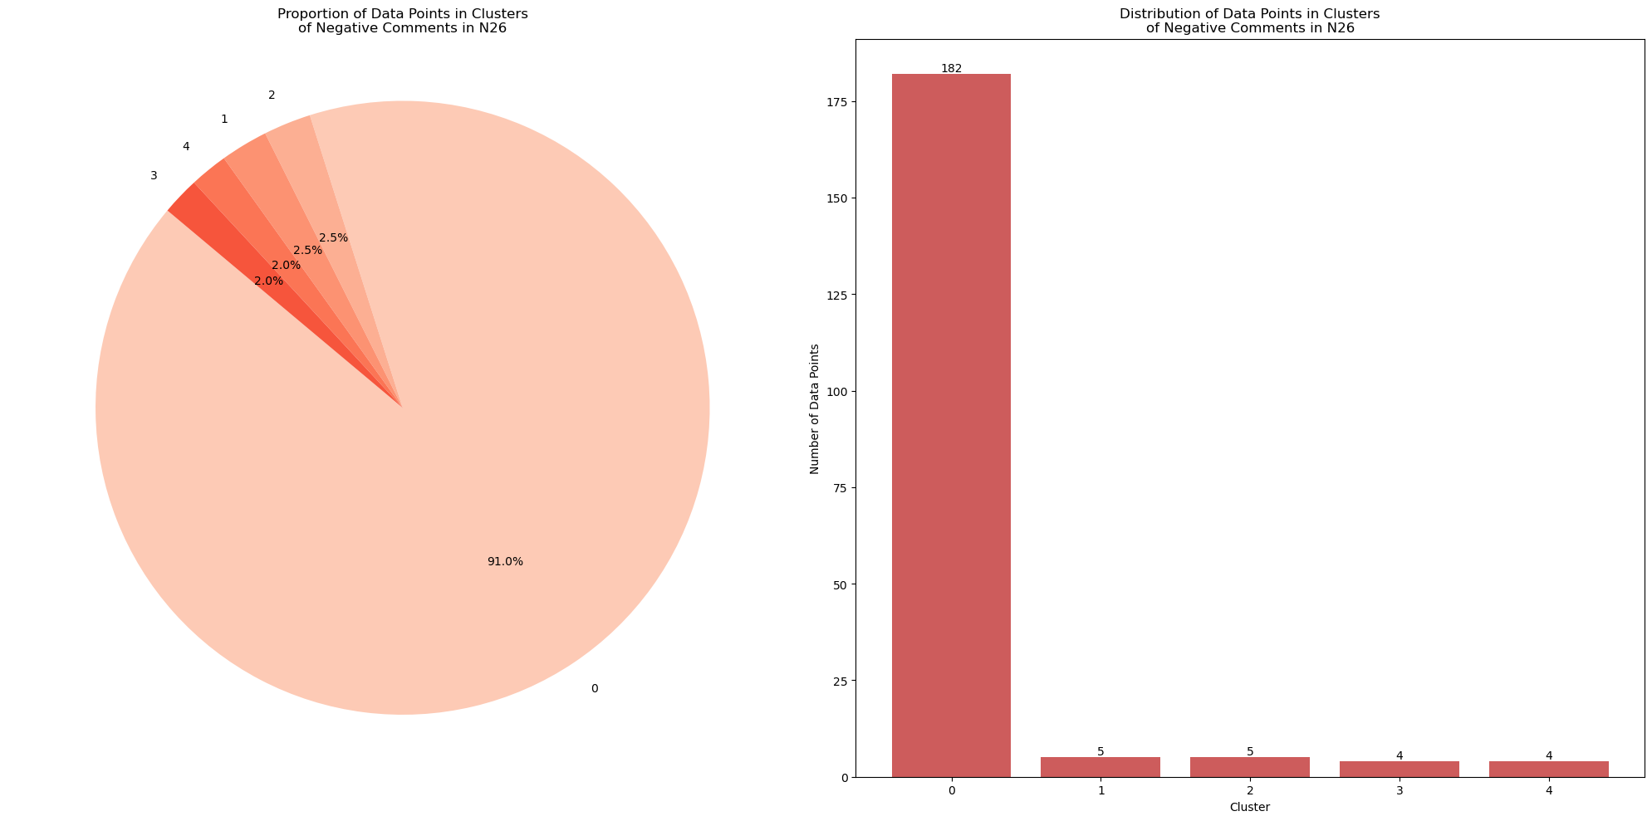

It is noticeable that **cluster 0** stands out with the largest share, encompassing **91% or 162 comments**, indicating that employees have concerns regarding *internal politics, high turnover rates, and management crises the most.* This suggests *dissatisfaction with the organizational environment and instability in leadership.*

**5.5 Employee Sentiment Analysis**

For this section, I calculated the **average sentiment scores** for positive (‘Pros_cleaned’) and negative (‘Cons_cleaned’) comments from Deutsche Bank and N26’s employees first.

***Figure 31:*** *Average sentiment scores for positive and negative reviews of both companies*

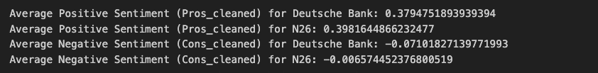

As you can see, **the average sentiment scores for the positive reviews (“Pros_cleaned”) is *higher for N26 (~0.398)*** compared to ***Deutsche Bank (~0.379),*** indicating *a more positive perception of employee satisfaction at N26 in comparison to Deutsche Bank.*

On the negative side, **the average sentiment scores for “Cons_cleaned” is *less negative for* *N26 (~0.006)*** than for ***Deutsche Bank (~0.071),*** indicating that *negative comments about N26 are less severe or less frequent than Deutsche Bank.*

Then, I created histograms to represent **the distribution of sentiment scores** for positive (“Pros_cleaned”) and negative (“Cons_cleaned”) comments from Deutsche Bank and N26’s employees. ***These distributions can provide a visual comparison of employee satisfaction levels between the two banks.***

***Figure 32:*** *Distribution of sentiment scores for positive and negative reviews of both companies*

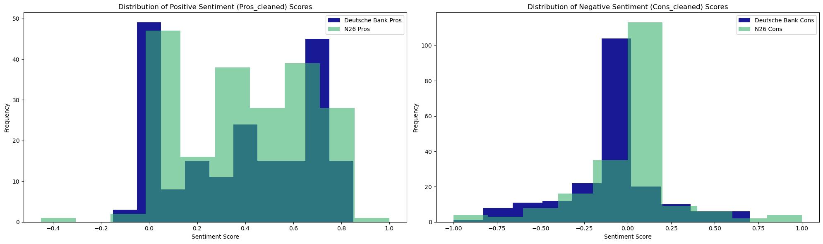

In the “Pros_cleaned” histogram, **N26 has a slight lead in higher positive sentiment.** This suggests that ***N26’s employees might be expressing more positive sentiments in their comments.***

On the “Cons_cleaned” histogram, there is a noticeable difference; **Deutsche Bank has more negative feedback compared to N26**. This could imply that ***issues at Deutsche Bank may be more severe or more frequently mentioned than at N26.***

In the next step, I define a function called *‘sentiment_label’* applied to the positive (‘Pros_cleaned’) and negative (‘Cons_cleaned’) review columns of both datasets to **analyze sentiment text data and return a sentiment label *(‘positive’, ‘negative’, or ‘neutral’)*** **based on the polarity score.** The *‘sentiment_label’* function categorizes the polarity score of text data into three distinct labels: **‘positive’** *if the score is greater than 0,* **‘negative’** *if it is less than 0,* and **‘neutral’** *if the score is exactly 0.*

***Figure 33:*** *The polarity score for the sentiment label on both datasets*

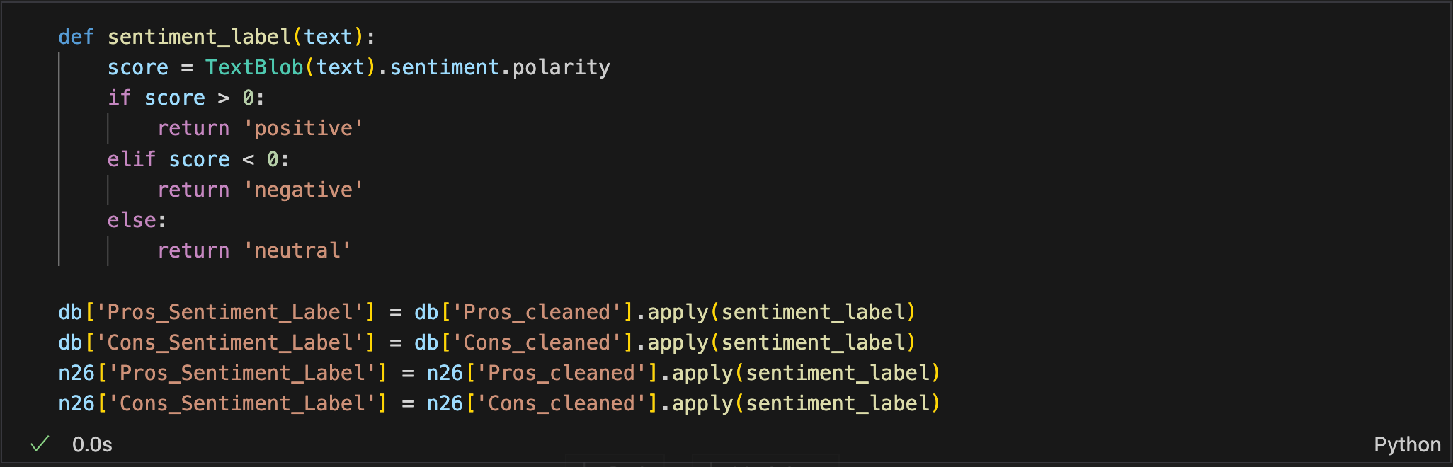

Then, I visualize **the distribution of sentiment labels** for both Deutsche Bank and N26 across positive (‘Pro_cleaned’) and negative (‘Cons_cleaned’) reviews. For readability, I set colors by *green* for **‘positive’**, *orange* for **‘neutral’**, and *red* for **‘negative’.**

***Figure 34:*** *Distribution of Employee Sentiment while Working at Deutsche Bank and N26*

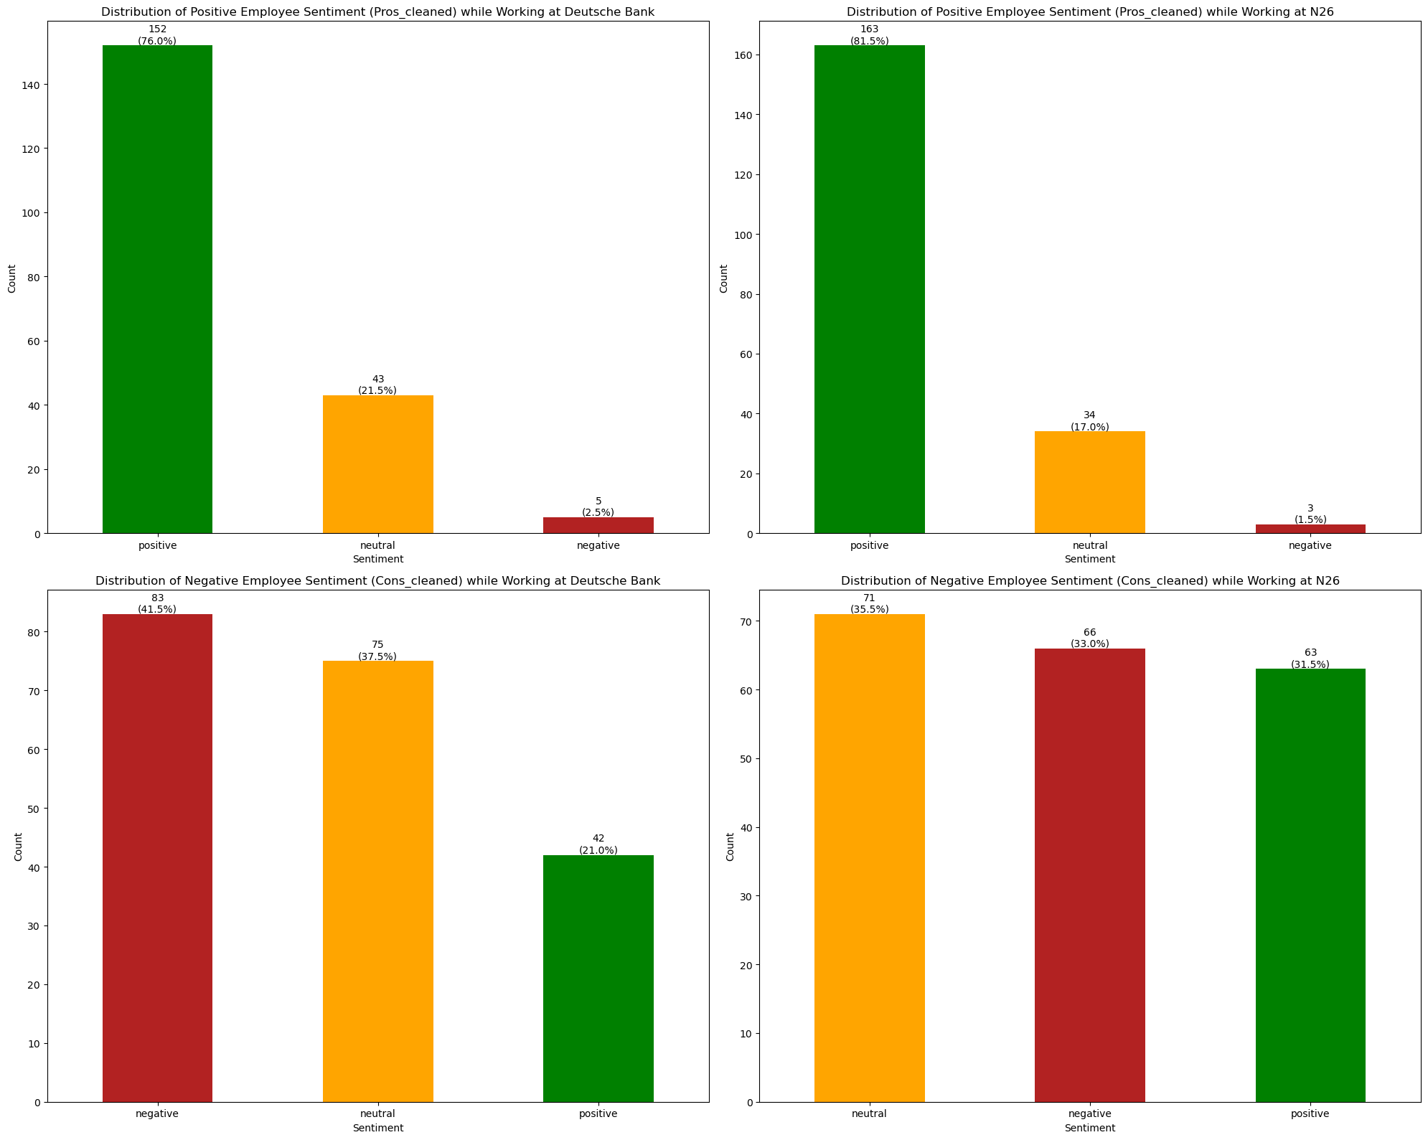

For the positive reviews, the “Pros_cleaned” chart of Deutsche Bank shows ***a large majority of sentiments are positive*** *(76% or 152 comments),* ***with a smaller proportion being neutral*** *(21.5% or 43 comments)* and ***very few negative*** *(2.5% or 5 comments).* Meanwhile, the “Pros_cleaned” chart of N26 also displays ***predominantly positive sentiments*** *(81.5% or 163 comments),* accompanied ***by a moderate amount of neutral*** *(17% or 34 comments)* and ***a minimal number of negative sentiments*** *(1.5% or 3 comments).*

For the negative side, the "Cons_cleaned" chart of Deutsche Bank presents ***a predominant negative sentiment*** *(41.5% or 83 comments),* followed by ***a substantial neutral sentiment*** *(37.5% or 75 comments*), and **some positive sentiment** *(21% or 42 comments).* On the other hand, the "Cons_cleaned" chart of N26 is slightly different from Deutsche Bank's, with ***neutral sentiments being the majority*** *(35.5% or 71 comments),* ***negative sentiments in the middle*** *(33% or 66 comments),* and ***positive sentiments being the least*** *(31.5% or 63 comments).*

Overall, I could safely say that ***N26’s employees tend to express slightly more positive sentiments compared to those at Deutsche Bank*.** However, ***the sentiment among Deutsche Bank employees appears to be more negative overall.*** Interestingly, *while the majority of negative comments at Deutsche Bank lean towards a negative sentiment, N26 exhibits a different pattern, with a significant portion of negative comments being perceived as neutral.*

1. **Results**

To achieve my research question ***(how do employee reviews reflect the differences in job satisfaction and organizational culture between traditional banks (Deutsche Bank) and FinTech companies (N26)?),*** I aim to create a comprehensive analysis by initializing a dictionary to track the count of sentiments associated with specific keywords *(‘salary’, ‘benefits’, ‘colleague’, ‘team’, ‘manager’, ‘leader’, ‘management’, ‘work-life balance’, ‘culture’, ‘environment’, ‘promotion’, ‘career’, ‘growth’, and ‘opportunity’).* The sentiments are categorized as *positive, neutral, and negative* with different keywords, providing ***insights into the sentiment distribution with various work aspects of employee experiences at both Deutsche Bank and N26.***

***Figure 35:*** *Sentiment distribution with various aspects of Deutsche Bank and N26’s employees*

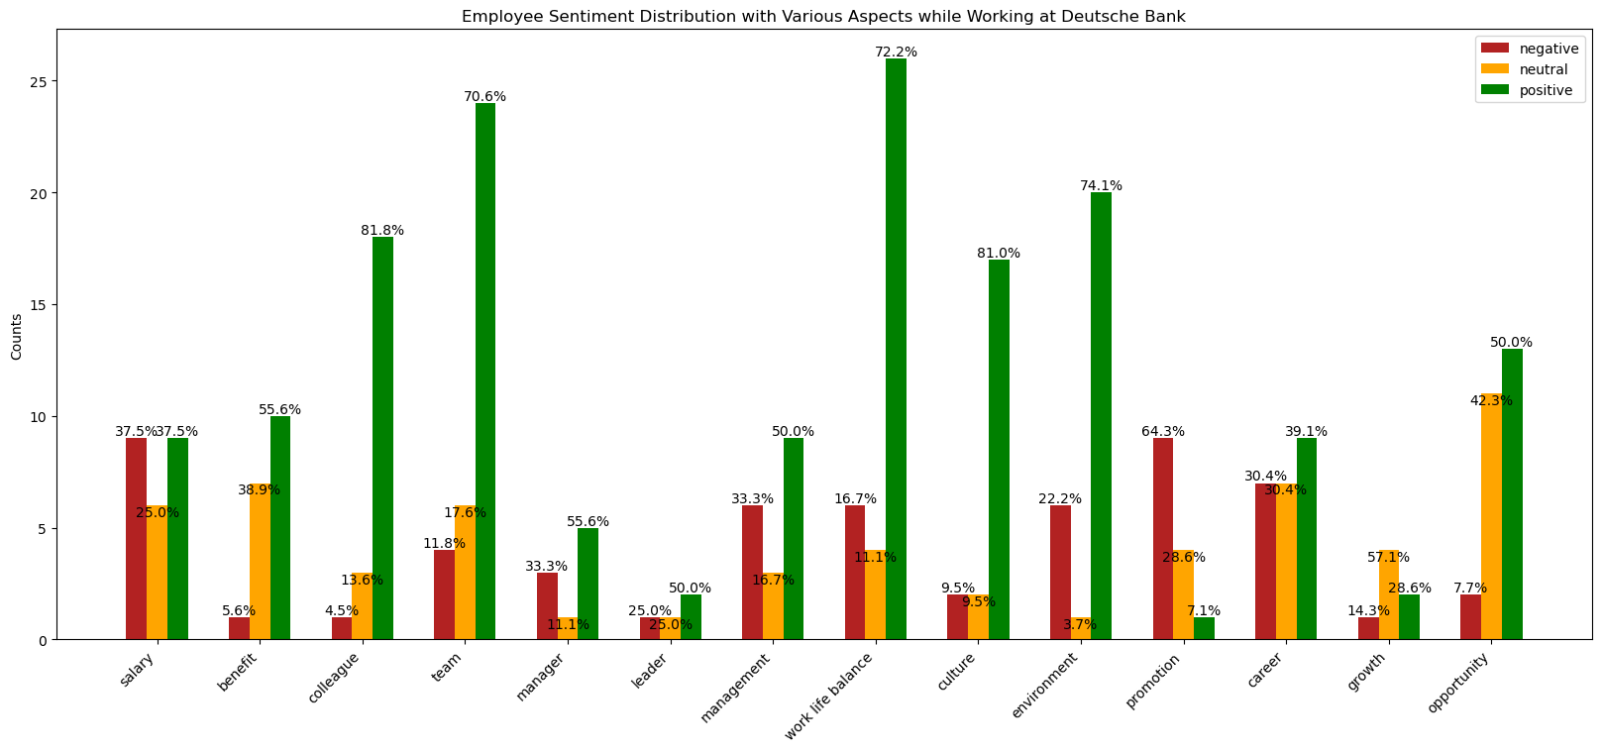

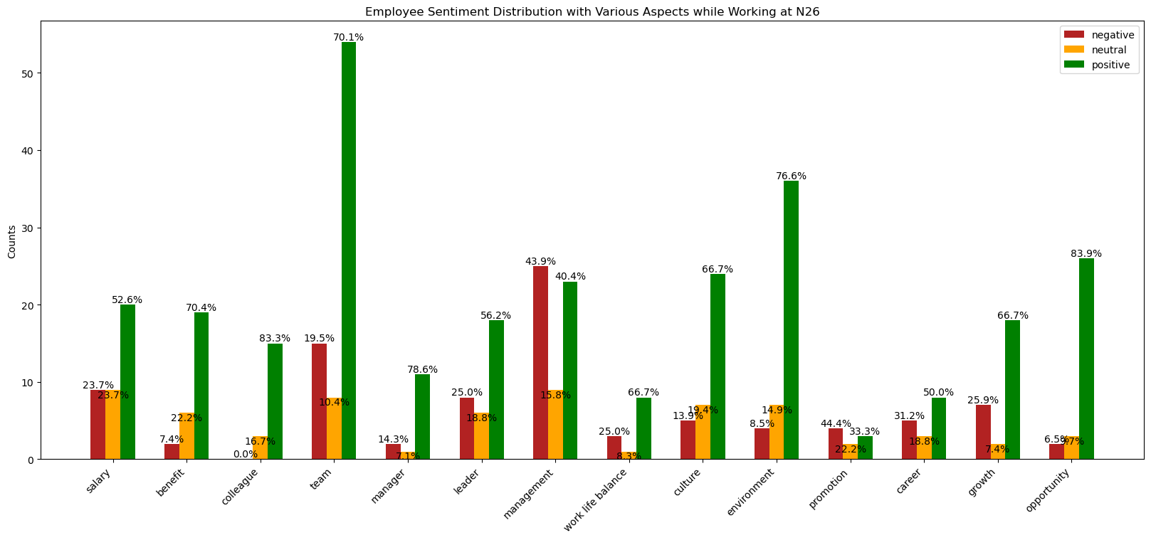

To compare employee sentiment between traditional banks (Deutsche Bank) and FinTech companies (N26), it is essential to consider various work aspects that may differ between the two types of organizations as follows:

1. **Compensation *(‘salary’ and ‘benefit’):***

At Deutsche Bank, the sentiment towards **‘benefit’** leans *predominantly positive*, with *approximately 55.6% of comments expressing satisfaction.* However, the sentiment spread for **‘salary’** appears *more balanced, with around 37.5% of comments being positive and negative*, suggesting ***potential variations based on factors such as work experience and job positions.*** In contrast, N26 employees *overwhelmingly express positive sentiments* regarding both**‘salary’***(approximately 52.6%) and* **‘benefits’** *(around 70.4%).* This indicates ***a notable difference in employee perception between the two organizations, with N26's compensation structures being well-received and potentially contributing to a positive organizational culture.*** The higher satisfaction levels at N26 may reflect a strategic emphasis on competitive and appealing remuneration packages to attract and retain talent in the rapidly evolving FinTech industry.

1. **Collaboration *(‘colleague’ and ‘team’):***

Both companies exhibit *a notably strong positive sentiment* towards both the **‘colleague’** and **‘team’** aspects, with *approximately 81.8% and 83.3% of comments expressing satisfaction with* **‘colleagues’**, and *around 70.6% and 70.1% showing positivity towards* **‘teamwork’** at Deutsche Bank and N26, respectively. These findings reflect ***a cohesive and supportive workplace culture characterized by peer support, teamwork, and collaboration in both organizations.*** However, it is noticeable that while the sentiment towards **‘team’** *remains predominantly positi*ve, there are some amount of negative and neutral sentiments across both companies. This nuanced sentiment distribution may indicate ***potential variations in individual relationships or experiences among staff members within the team dynamics.***

1. **Management and Leadership *(‘manager’, ‘leader’, and ‘management’):***

Both companies exhibit *a predominantly positive sentiment* towards the **‘manager’** and **‘leader’** aspects, with *approximately 55.6% and 78.6% of comments expressing satisfaction with* **‘manager’**, and *around 50% and 56.2% showing positivity towards* **‘leader’** at Deutsche Bank and N26, respectively. However, there is *a notable presence of negative sentiment* towards **‘manager’**, accounting for *around 33.3% at Deutsche Bank*, and towards **‘leader’**, *with 25% at N26*. This suggests ***a diverse employee experience that may correlate with different management levels or styles within each organization.*** While the majority of employees may express satisfaction with their leaders, the presence of negative feedback highlights the need for potential improvements, such as refining leadership practices or addressing specific concerns raised by employees. In contrast, N26 displays *a higher level of negative sentiment, with approximately 43.9%* in **‘management’** aspect compared to Deutsche Bank. This disparity may indicate ***challenges or dissatisfaction among N26 employees regarding leadership practices or organizational management structures.*** It suggests areas where N26 could focus on implementing strategies, such as fostering open communication channels between management and employees to foster a more positive and supportive work environment that aligns with the innovative and dynamic culture typically associated with FinTech companies.

1. **Work-Life Balance *(‘work life balance’):***

Both companies *tend to exhibit a strong positive sentiment* in the **‘work life balance’** aspect, with interestingly *Deutsche Bank showing a significantly higher level of positivity compared to N26, around 72.2% and 66.7%, respectively.* This suggests that ***employees at Deutsche Bank may perceive the organization as placing a greater emphasis on promoting and maintaining a healthy work-life balance compared to their counterparts at N26.*** The higher level of positivity in this aspect at Deutsche Bank may indicate that the traditional bank has implemented effective policies, practices, and initiatives to support employees in achieving a satisfactory balance between their professional and personal lives.

1. **Company Culture *(‘culture’ and ‘environment’):***

Employees of both companies perceive significantly positive sentiment in the **‘culture’** and **‘environment’**, with *approximately 81% and 66.7% of comments expressing satisfaction with* **‘culture’**, and *around 74.1% and 76.6% showing positivity towards* **‘environment’** at Deutsche Bank and N26, respectively. This indicates that ***employees feel supported, valued, and comfortable in their respective work settings at both organizations.***

1. **Career Progression *(‘promotion’, ‘career’, ‘growth’, and ‘opportunity’):***

At Deutsche Bank, the sentiment regarding career opportunities seems more mixed, with a considerable number of employees reporting neutral experiences. The distribution of sentiments is fairly even across positive, neutral, and negative, which suggests that experiences with career opportunities may vary widely among employees. For instance, while the **‘career’** and **‘opportunity’** aspects *show positivity in sentiment, around 39.1% and 50%,* respectively, the sentiment towards **‘growth’** appears *to be neutral, with approximately 57.1%.* Notably, the aspect of **‘promotion’** exhibits *a significantly high level of negativity, around 64.3%.* This could indicate that ***while employees at Deutsche Bank may perceive opportunities for career advancement, there could be perceived barriers or inconsistencies in the process or availability of promotions, leading to dissatisfaction or frustration among some employees***.

For N26, there is *a significantly higher proportion of positive sentiments* related to the **‘career’, ‘growth’,** and **‘opportunity’** aspects*, with approximately 50%, 66.7%, and 83.9%*, respectively, except **‘promotion’**, which shows *a higher prevalence of negative sentiment, at around 44.4%.* The majority of employees have shared positive reviews, indicating ***a strong culture of promoting career growth and providing opportunities within the FinTech company.*** The low percentage of negative sentiment might suggest that ***barriers to career advancement are less common, or that such issues are not as impactful on employees' perceptions of their career opportunities at N26.***

Overall, N26 appears to have a more favorable employee perception of career opportunities when compared to Deutsche Bank. The high positive sentiment at N26 could be reflective of a dynamic, growth-oriented culture often found in FinTech startups, which may provide more agility and openness to employee advancement. In contrast, the more traditional and possibly hierarchical structure at Deutsche Bank might contribute to the mixed feelings, as progression may be seen as more rigid or conventional.

1. **Conclusion including Limitations and Outlook**

**7.1 Conclusion**

To sum up, I would like to make a snapshot of all key findings for easy readability as follows:

***Table 4:*** *Key findings for exploratory data analysis (EDA) section*

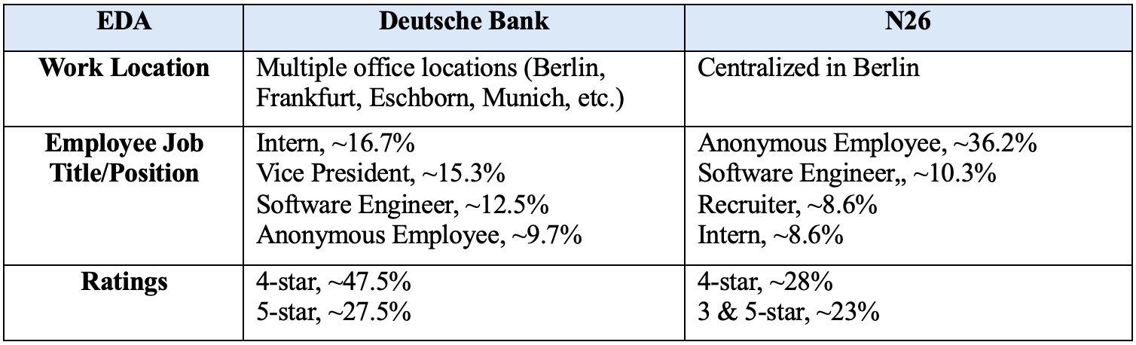

***Table 5:*** *Key findings for topic modeling section*

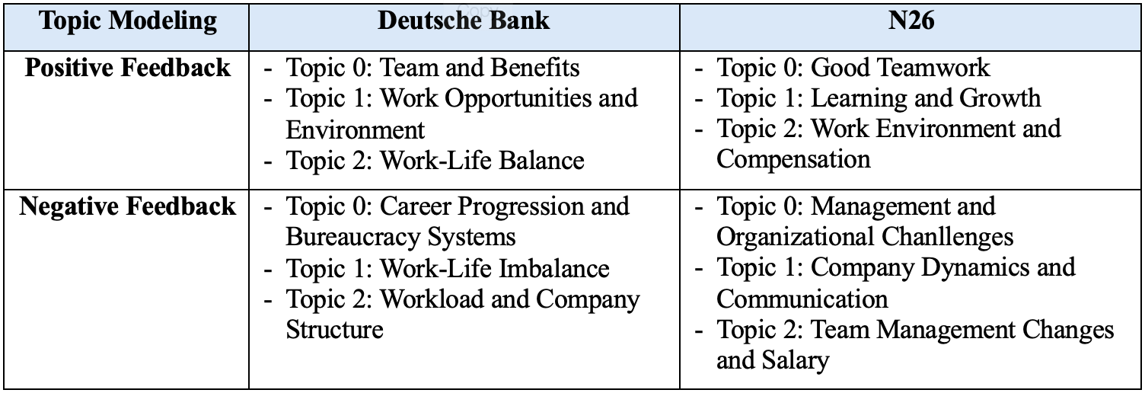

***Table 6:*** *Key findings for clustering classification section*

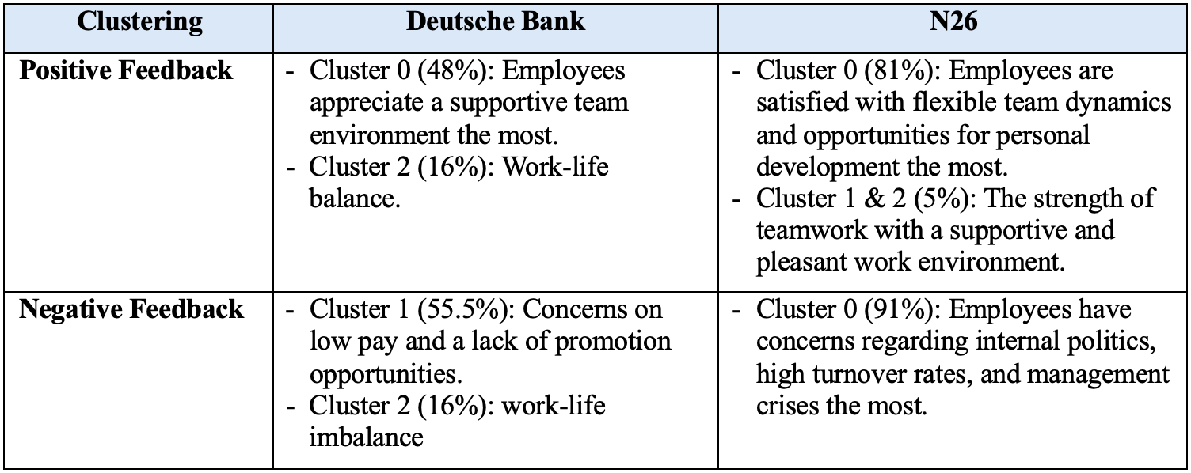

***Table 7:*** *Key findings for employee sentiment analysis section*

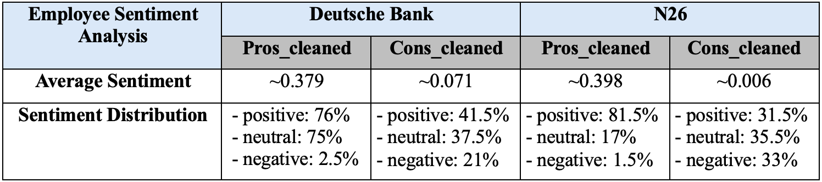

***Table 8:*** *Key findings for employee sentiment analysis through work aspects*

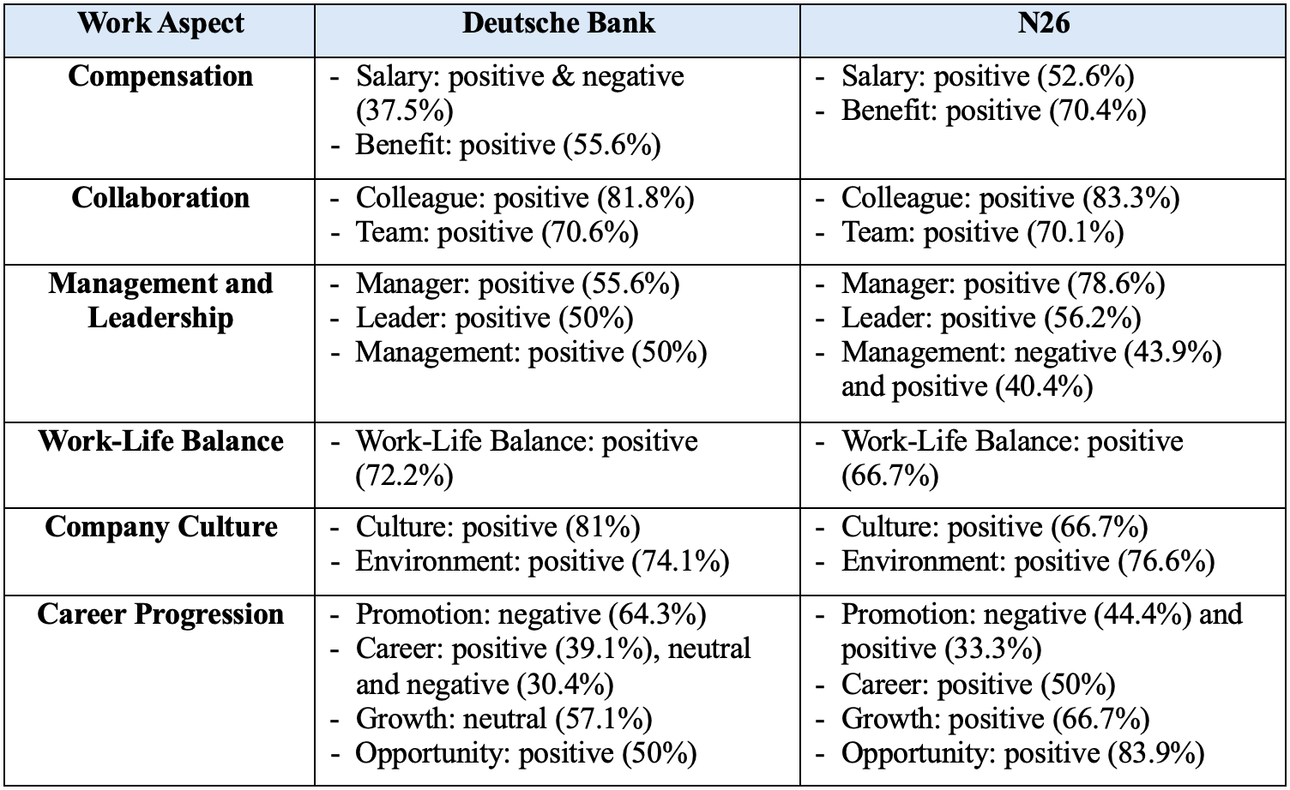

In summary, my analysis of employee reviews provides clear differences in job satisfaction and organizational culture between Deutsche Bank, a traditional bank, and N26, a FinTech company. While both exhibit strengths in collaboration, work-life balance, and company culture, distinct perceptions emerge in compensation and career progression. N26 employees express predominantly positivity towards salary, benefits, and career opportunities, reflecting a robust emphasis on competitive compensation and a growth-oriented culture. In contrast, while Deutsche Bank receives favorable feedback on benefits, sentiments towards salary are more nuanced, suggesting potential variations in compensation satisfaction. Additionally, perceptions of management and leadership differ, with Deutsche Bank generally exhibiting higher satisfaction levels. Conversely, negative sentiment towards management is more prevalent at N26, suggesting potential challenges in leadership practices. Overall, these insights underscore the imperative for traditional banks to adapt to changing employee expectations and industry dynamics to enhance job satisfaction and foster a positive organizational culture, aligning with the practices seen in innovative FinTech companies like N26.

**7.2 Limitations**

However, I acknowledge that these findings may not completely represent the experiences of all employees within traditional banks and FinTech companies. Therefore, it is essential to consider the following limitations.

1. ***Bias in Reviews:*** Glassdoor reviews may be biased, as extreme opinions are more likely to be expressed, potentially skewing the analysis.
2. ***Temporal Considerations:*** Employee sentiments can change over time due to various factors. Analyzing reviews at a single point may not capture these variations adequately.
3. ***Data Quality:*** Data reliability from Glassdoor reviews varies, and automated sentiment analysis may not always accurately capture nuances.
4. ***Generalizability:*** Findings from Deutsche Bank and N26 reviews may not apply to all traditional banks or FinTech firms in Germany due to factors like organizational culture and location.
5. ***Limited Scope:*** Reviews from Glassdoor may not capture all work aspects of the employee experience such as attitudes toward innovation and technology adoption, including diversity and inclusion efforts.

Addressing these limitations will lead to a more comprehensive assessment of the project's constraints and considerations.

**7.3 Outlook**

To conduct a more comprehensive comparative analysis, it is valuable to explore additional methods for further research and to consider the potential applications of the findings.

1. ***Further Comparative Analysis:*** Including more traditional banks and FinTech firms in diverse regions or similar market scales can provide a broader perspective on job satisfaction and organizational culture in Germany's banking sector.
2. ***Longitudinal Study:*** Tracking changes in employee sentiment over time within Deutsche Bank and N26 could reveal trends or patterns in job satisfaction and organizational culture evolution.
3. ***Impact of External Factors:*** Exploring how regulations, market trends, and technological advancements interact with job satisfaction and organizational culture can enhance the interpretation of findings.
4. ***Employee Retention and Performance:*** Analyzing the relationship between employee sentiment, retention rates, and performance metrics could provide actionable insights for human resource management.
5. ***Cross-Cultural Analysis:*** Conducting cross-cultural analyses on job satisfaction between traditional banks and FinTech companies can assess the impact of cultural factors across diverse contexts.

Exploring these methods can provide valuable insights into job satisfaction, organizational culture, and employee sentiment within the banking sector.

1. **References**

Bordoloi, M., & Biswas, S. K. (2023). *Sentiment analysis: A survey on design framework,*

*applications and future scopes.* Artificial intelligence review, 1–56. Advance online publication. <https://doi.org/10.1007/s10462-023-10442-2>

Chin, Chiew. (2020). *Text Analytics On Company Reviews In Jobstreet.* European Proceedings

of Social and Behavioural Sciences. <https://www.researchgate.net/publication/340293535_Text_Analytics_On_Company_Reviews_In_Jobstreet>

Feng, S. (2023). *Job satisfaction, management sentiment, and financial performance: Text*

*analysis with job reviews from indeed.com.* International Journal of Information Management Data Insights. <https://www.sciencedirect.com/science/article/pii/S2667096823000022#section-cited-by>

Frank, F. F., & Whittle, T. E. (n.d.). *Predicting company ratings through Glassdoor Reviews.*

Department of Management Science and Engineering Stanford University.

<https://web.stanford.edu/class/archive/cs/cs224n/cs224n.1184/reports/6880837.pdf>

H. Yadav, K. Dwivedi and G. Abirami. (2022). *Sentiment Analysis of company reviews using*

*Machine Learning.* 2022 3rd International Conference for Emerging Technology (INCET), Belgaum, India. <https://ieeexplore.ieee.org/document/9824505>

Höllig, C. E. (2021). *Online Employer Reviews: Text-Mining Analyses of Contents, Effects, and*

*Employer Responsiveness.* TUM School of Management. <https://mediatum.ub.tum.de/doc/1594000/1594000.pdf>

Jung, Y., & Suh, Y. (2019). *Mining the voice of employees: A text mining approach to identifying*

*and analyzing job satisfaction factors from online employee reviews.* Decis. Support Syst., 123. <https://api.semanticscholar.org/CorpusID:196185822>

Luo, N., Zhou, Y., & Shon, J. (2016). *Employee Satisfaction and Corporate Performance:*

*Mining Employee Reviews on Glassdoor.com.* International Conference on Interaction Sciences. <https://core.ac.uk/download/pdf/301370386.pdf>

Martinez, L. D. (2019). *Improving employee satisfaction through text analytics.* SESUG Paper.

<https://www.lexjansen.com/sesug/2019/SESUG2019_Paper-243_Final_PDF.pdf>

Morshed Adib, M. & Chakraborty, S. & Waishy, M. & Mehedi, M. H. K. & Rasel, A. A. (2023).

*BiLSTM-ANN Based Employee Job Satisfaction Analysis from Glassdoor Data Using Web Scraping.* Procedia Computer Science. <https://www.researchgate.net/publication/373570703_BiLSTM-ANN_Based_Employee_Job_Satisfaction_Analysis_from_Glassdoor_Data_Using_Web_Scraping>

Ramanathan, V. & Thirunavukkarasu, M. (2019). *Prediction of Individual’s Character in Social*

*Media Using Contextual Semantic Sentiment Analysis.* Mobile Networks and Applications. 24. <https://doi.org/10.1007/s11036-019-01388-3>

Uchida, E., Kino, Y. (2021). *Study on the relationship between employee satisfaction and*

*corporate performance in Japan via text mining.* Procedia Computer Science. <https://www.sciencedirect.com/science/article/pii/S1877050921016732>

Uyeno, L. (2020). *An empirical analysis of company culture: Using Glassdoor data to measure*

*the impact of culture and employee satisfaction on performance.* Scholarship @ Claremont. <https://scholarship.claremont.edu/cmc_theses/2293/>

Young, L. M., & Gavade, S. R. (2018). *Translating emotional insights from hospitality*

*employees’ comments: Using sentiment analysis to understand job satisfaction.* International Hospitality Review. <https://www.emerald.com/insight/content/doi/10.1108/IHR-08-2018-0007/full/html>